CM3070

Breast Cancer Mammography with CNNs

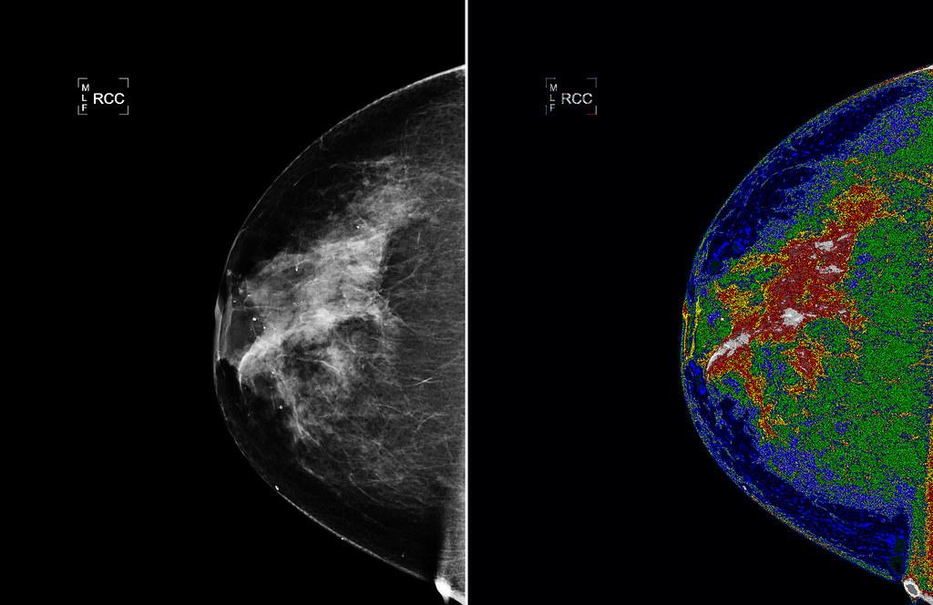

Introduction
Template: Deep Learning Breast Cancer Detection
Breast cancer is one of the most common cancers diagnosed in women within the United Kingdom, with 59,413 new cases per year and around 11,200 deaths per year (Cancer Research UK, 2025). The NHS Breast Screening Programme is the primary organization in the UK with roles in early detection and routine mammography to aid the objective of reducing deaths from breast cancer. This programme prevents roughly 1,300 deaths per year (Marmot et al. 2012). Despite the success of the programme, this programme consumes additional resources in the form of double-reading.
Double reading is the practice of using two independent radiologists to provide a diagnosis. Double reading is the standard for the NHS Breast Screening Programme, and uses the time of two qualified radiologists. This contributes to workforce strain, variable turnaround, and occasional diagnostic delays (Marmot et al. 2012) (Freeman et al. 2021).
And while X-Ray mammography is widely regarded as the standard for breast cancer screening, there are well-documented limitations in sensitivity (TP/(TP+FN)) and specificity (TN/(TN+FP)). This is prevalent in women with dense breast tissue (Wang 2024). These limitations combined with rising screening volumes, and shortages of radiologists, have formed the demand for alternative solutions. One of these is the utilization of artificial intelligence to provide the second opinion that double-reading currently does. In August 2025, the NHS launched a major research initiative to see if deep learning systems could support or replace the second radiologist in the current double-reading standard. If successful, more patients could be processed faster and potentially with more accuracy. This would reduce pressure on specialists, and free up clinician time for more complex cases (Taylor-Phillips 2025).
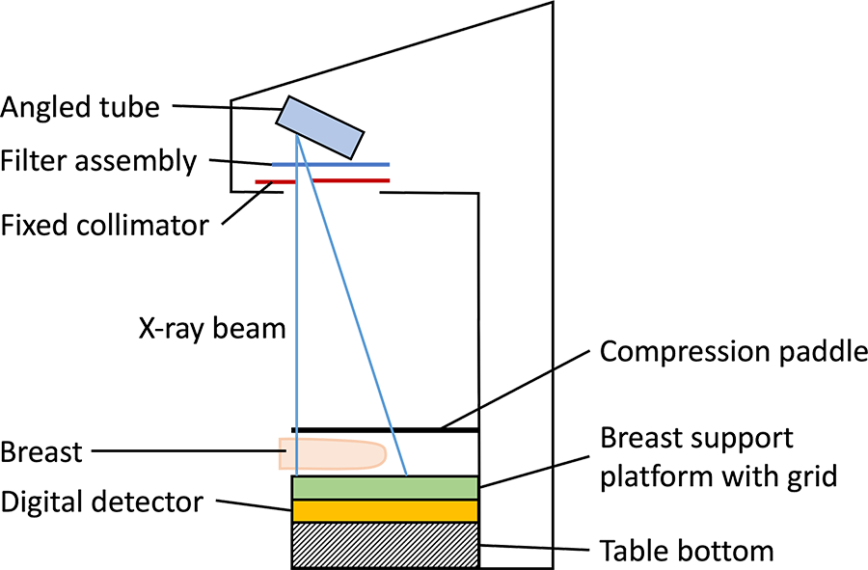
Mammography machine diagram for capturing carniocaudal view (top-view) (Radiology Cafe 2026).
Since the mammogram produced from mammography can be interpreted as an image, Convolutional Neural Networks are well suited for the domain. CNNs can learn hierarchical features directly from the mammogram regardless of the feature’s position in the image, which is key to detecting breast cancer accurately (Chollet 2018, Wang. 2024). Wang in her 2024 paper notes “CNN has several advantages over traditional mammography screening, including higher accuracy, faster processing, and the ability to identify subtle changes in mammograms.” (Wang. 2024).
This project will follow the CNN deep learning workflow established by Chollet, and has also explored a few experimental alternatives not completely in line with the Chollet style CNN workflow. This entails systematic data preparation, augmentation, model construction, transfer learning, training, regularisation, and callbacks. Evaluation will be done through medically relevant metrics such as Area Under Curve - Receiver Operator Characteristic, sensitivity, specificity, and F1 scores. By using an established workflow and well established dataset, this project aims to provide reproducible evidence of performance (Chollet 2018).
For patients, success of this project or a similar project could lay the groundwork for faster and more accurate screening. This could reduce anxiety, and serve the patient’s health via additional diagnostic accuracy. As previously mentioned - the project could potentially eliminate the need for a double-reading freeing up a radiologist to process more scans if this project or a similar project is integrated in a workflow with actual external testing and clinical trials. However, it’s important to add the disclaimer that there are limitations in the sense that a model that benchmarks well in internal tests may not translate well to real clinical performance. CBIS-DDSM has ~9 percent patient leakage between training and testing, and on top of that there’s a demographics mismatch and equipment mismatch (Freeman et al. 2021, Wang 2024).
Further details will be covered in the literature review.

Literature Review Introduction
This chapter will look at the existing body of research for deep learning approaches for breast cancer detection in mammography. We’ll look at breast cancer screening as a whole, the use of CNNs for medical imaging, the datasets and evaluation processes commonly used, and the ethical considerations for using such techniques in the real world.

Breast Cancer Screening Context
Breast cancer as a whole is currently a significant strain on the UK National Health Service. Cancer Research UK (2025) reports approximately 59, 413 new cases annually with around 11, 200 deaths per year as of 2025. Breast cancer is a significant enough problem such that in 1986, Professor Sir Patrick Forrest wrote a report recommending a mammography scan every 3 years in women aged 50-70 years old. His recommendation was adopted 1988, forming the modern NHS Breast Cancer Screening Programme (Forrest, 1986) (Marmot et al 2012).
The benefits of period screening are supported by multiple previous studies. In an independent panel commissioned by the UK government, periodic screening reduced breast cancer mortality by approximately 20 percent. This amounts to one life saved per 180 women participating in the programme averaged over a 20 year period. At the general population level, this amounts to approximately 1, 300 lives saved per year (Marmot et al 2012).
In the same review from Marmot et al, there are some downsides to the programme. For every 10,000 women invited to screening aged 50 and up, 129 cancers would be overdiagnosed. These cancers are those which aren’t likely to adversely affect the health of the patient, but the patient still goes through any combination of treatment, surgery, radiotherapy, and chemotherapy. This creates strain on the healthcare system and the patient. False-positives are also costly, since this creates anxiety for the patient and psychological harm (Marmot et al 2012)(Freeman et al. 2021).

To reduce misdiagnosis, the NHS Breast Screening Programme mandated the standard of double reading. This is the practice of having two independent radiologists interpret every mammogram. Double reading improves sensitivity (rate of finding true positives), and leads to more accurate readings. But the downside is now two radiologists are needed to go over every scan, leading to workforce strain and delayed findings. Retention issues and workforce shortages are additional factors which makes it difficult to employ double-reading as a standard (Department of Health and Social Care 2025).

Architecture and Dataset Overview
Lulu Wang in 2024 conducted a review for the use of CNNs for classifying breast cancer over various studies. Most approaches used were CNNs instantiated with weights from ImageNet and then fine-tuned on mammography data, with different preprocessing steps taken like denoising and normalization. The best prediction performance in the different studies came from averaging predictions from multiple models or multi-task learning. For segmentation of the tumor - some form of U-net is the most commonly used type of architecture used in the examples that perform segmentation. CNNs or GANs were also used for segmentation but don’t provide as strong performance as U-net. And finally for the dataset used, most studies used some form of CBIS-DDSM, DDSM, INbreast or VinDr-Mammo. The rest of the literature review will be exploring each of these elements more closely (Wang 2024).

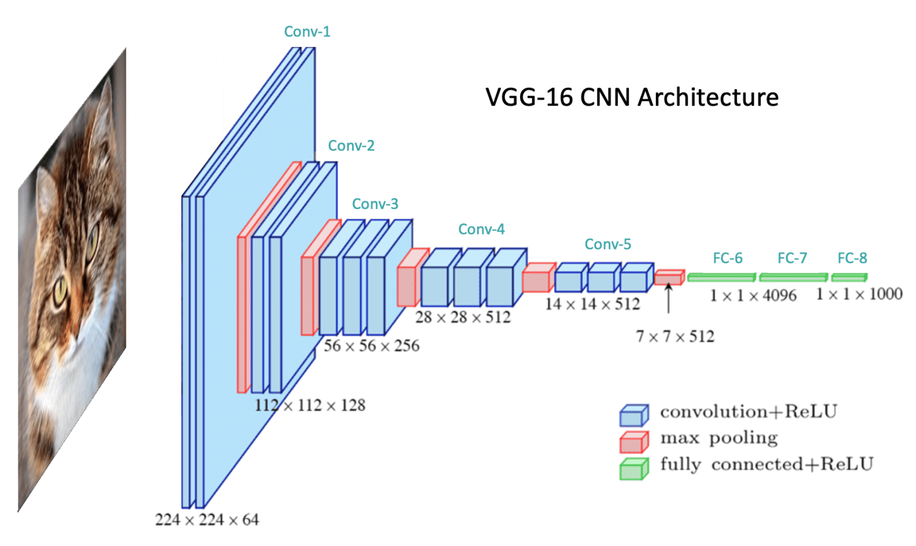
VGG-16 CNN architecture diagram (Kromydas 2023).
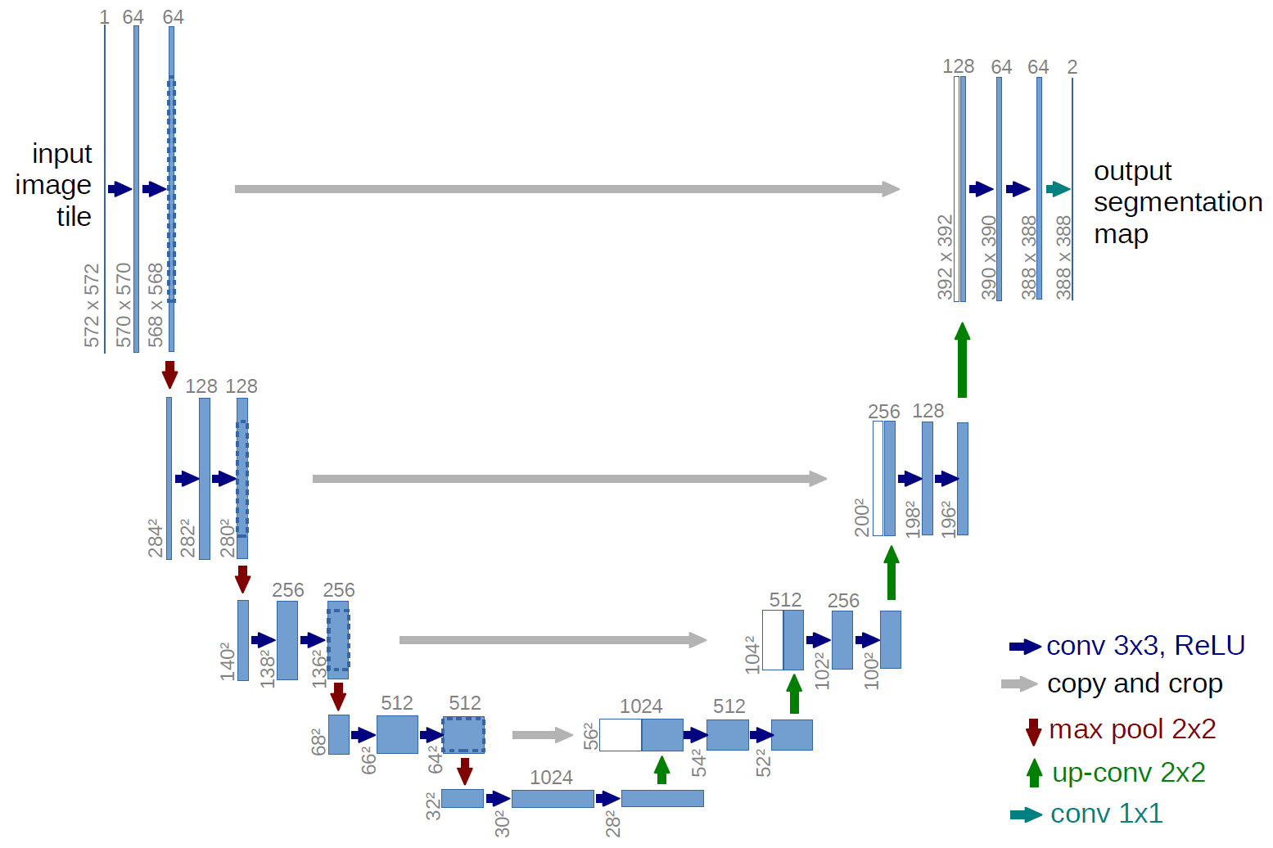
Diagram of typical size U-Net (Ronneberger, Fischer and Brox 2015).

Datasets
As with any deep learning project - the quality of the dataset matters immensely in training a capable model. The three prominent datasets used in Wang’s study overview are CBIS-DDSM, DDSM, and INbreast. Starting off with DDSM, DDSM stands for “Digital Database for Screening Mammography”. This database was originally made via a U.S. Department of Defence grant with four collection sites distributed throughout the mainland U.S, and consists of 2620 cases of digitized film-screen mammograms with associated pathology information (Bowyer et al. 1996). While its size is attractive as a prospective benchmark, this database was ultimately not made with machine learning workflows in mind. Annotations are inconsistent for segmentation workflows, and this inspired the development of the CBIS-DDSM (Lee et al. 2017).
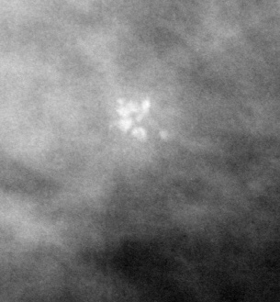
Example of zoomed in tumor from CBIS-DDSM (Lee et al. 2017).
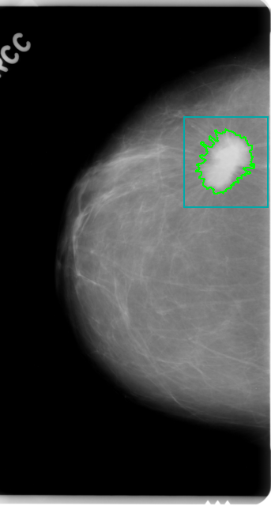
Example image from CBIS-DDSM with bounding box (Lee et al. 2017).
Rebecca Sawyer Lee in 2017 alongside Francisco GImenez, Assaf Hoogi, Kanae Kawai Miyake, Mia Gorovoy, and Daniel L. Rubin developed CBIS-DDSM with the goal of adapting DDSM for modern computer aided detection workflows. This includes improved lesion annotations for segmentation, pathology labels, pre-determined train/test splits, and metadata. Studies such as Shen et al. 2019, Li et al. 2022 use CBIS-DDSM as their core dataset. Due to its built out compatibility with modern deep learning workflows, a large variety of studies about CNNs in breast cancer detection use CBIS-DDSM as both their training data and testing data. CBIS-DDSM’s prevalence also has a very desirable side-effect, it provides a common benchmark versus other deep learning approaches which use it as its training data. However - there’s a big caveat though in practice, most of the studies in Wang’s review vary in their data splitting or pre-processing. Whether this is k-fold validation and not using the official train/test split, pairing images for two-view workflows, different image format/variants, there’s typically some deviation which doesn’t allow for 1:1 comparison between workflows (Wang 2024).
The last dataset I’ll touch on from Wang et al’s review is INbreast. INbreast is a newer, higher quality, and smaller mammography dataset composed of 115 full-field digital cases composed of 410 images with expert annotations and biopsy correlation (Moreira et al 2012). Saliha Zahoor, Umar Shoaib, and Ikram Ullah Lali in 2022 using INbreast have achieved 99.7% accuracy with AUCs of up to 1.00 using a fine-tuned version of MobileNetV2 with applicable optimization techniques. (Zahoor et al 2022) INbreast’s annotation and original digital format make it useful for transfer learning, but ultimately its small size makes it prone to overfitting (Wang 2024).
Two more datasets of interest that weren’t used in this project are VinDr-Mammo and NL-Breast-Screen. Both of these datasets are substantially larger full field digital mammogram datasets with per patient multi-views available, allowing for a workflow like Petrini et al. in 2022 without much data cleaning needed, but are heavily imbalanced and only have BI-RADS ratings (Kendall et al. 2025, Pham et al. 2022).
VinDr-Mammo consists of 20,000 images, which form 5,000 patient examples with BI-RADs ratings and bounding boxes. On top of this, it also has a pre-defined train/test split which allows for easy reproducibility for anyone else who uses the dataset to produce a CAD pipeline. This dataset is appealing as opposed to CBIS-DDSM due to its larger size, higher quality mammograms, strict multi-view examples, and similar pre-defined train/test split. But, ultimately it does not have pathology verified labels. In Petrini and Kim (2025), they achieved an AUC of ~ 0.833 for a single view patch pretrained EfficientNet-B3 on pathology verified CBIS-DDSM labels. Their VinDr-Mammo experiments involved training on BI-RADS 1-2 versus BI-RADS 3-5 grouped labels and achieved an AUC of 0.851 with ConvNeXt-Base pretrained on ImageNet-22k versus a DenseNet169 direct classifier at AUC of 0.813. Their two-view ConvNeXt patch model scored 0.851, above the 0.8019 obtained by averaging two view single scores. The main takeaway from their paper is that patch pre-trained pipelines outperformed direct classifiers on higher resolution FFDM scans, and ultimately with pathology verified labels a similar FFDM dataset would be the way forward for future iterations with patch pre-training (Pham et al. 2022, Petrini and Kim 2025).
NL-Breast-Screening is a dataset from Newfoundland in Canada consisting of 26, 988 images forming an example of 5, 935 pathology labels due to a similar four-view screening used by VinDr-Mammo. No major research studies have been released on this dataset at the time of writing, and it also doesn’t have a pre-defined train/test split, or bounding boxes. No bounding boxes makes it worth looking at as a future direct classifier FFDM example or an external testing dataset for a patch pre-trained model. Another benefit of this dataset is that it is demographically different from VinDr-Mammo, and so a model optimized or trained on both of these datasets would have strong generalization (Kendall et al. 2025).

Architectures
ImageNet pretrained CNNs can be fine tuned for mammography. Chougrad et al. (2018) fine-tuned InceptionV3, ResNet50, and VGG16 on a selection of DDSM images and reported accuracies of 97.35, 97.27, and 97.12 percent respectively with InceptionV3 having an AUC of 0.98. Very impressive on paper, but as Wang’s review highlights, the setup matters heavily in how these numbers are reported. These figures belong to an arbitrary subset of DICOM images, and on the official CBIS-DDSM split used in this project, a similar pipeline only achieved only AUCs of 0.704, 0.717, and 0.751 on InceptionV3, VGG16, and an ensemble of both respectively.

In Shen et al. 2019, the group established an end-to-end pipeline that starts with patch pre-training using the lesion-annotated regions of interest via ResNet50 and VGG16 and then converting the patch head into an entirely convolutional whole image model. After conversion, the network could be fine tuned on full mammograms using the pathology labels. Using this method on a custom 85/15 CBIS-DDSM split, they achieved an AUC of 0.91 on a single model. However, their approach somewhat falls apart when implemented upon the official CBIS-DDSM split, only achieving an AUC of 0.751 in Petrini and Kim’s reimplementation. I also found similar performance in my midterm implementation. However - the main attractiveness of this approach is that after initial patch training, additional examples don’t need annotated ROI annotations, which fit a real world deployment much better versus an approach which would need a clinician to paint regions of interest (Shen et al 2019, Petrini and Kim 2025).
But I’d also like to highlight EfficientNet-B3’s strong performance when used as a direct-classifier versus patch-based classifiers for CBIS-DDSM:
“For low-quality mammograms (CBIS-DDSM), we observed no significant benefit from patch-based pretraining approach; however, it significantly improved classification accuracy on high-quality mammograms ” (Petrini and Kim 2025)
What can be derived from this, is that while in theory we could spend our time chasing whatever performance is possible from training on CBIS-DDSM; ultimately an actual clinical deployment of a second-reader assistant system will eventually need to be optimized for FFDM scans via patch pre-training (Petrini and Kim 2025).
I’ll touch on segmentation despite not adopting it. For lesion segmentation, some version of the U-Net architecture is the most prevalent architecture used. Notable examples include CRU-Net, RU-Net, and MS-ResCU-Net. All architectures considered in the review were able to provide Dice performance of at least 0.93 or more on DDSM, CBIS-DDSM, and INbreast datasets (Wang 2024).

Evaluation
Performance reviewed in the literature typically stuck to using area under the Receiver Operating Characteristic (ROC) curve, accuracy, sensitivity, specificity, and Dice coefficients (for segmentation). The highest performing benchmarks exceed 95% accuracy or 0.90 AUC, with the caveat of a variance in splits, formatting, and datasets. Additionally - Wang notes that a large amount of these benchmarks are from internal validation on the same dataset used for training, even if there’s a train/test split, raising concerns about artificially inflated performance from overfitting for the particulars of the dataset used. It also doesn’t help that CBIS-DDSM has approximately 9% patient level contamination, which allows the model to train on patients that’d be found in the test split. The logistics of orchestrating external validation on a real clinical study is difficult, so it’s understandable why the majority of studies stick to internal validation (Wang 2024).

Ethics
Despite these promising results - we need to go over a few ethical considerations. Where did the data come from and is it correct to use it? Does it violate the rights of those it was collected from? Is it responsible to trust a black box to make medical decisions for real people? Despite strong performance in previous studies and potentially with this project, are we guaranteed to see the same performance in real world testing?
The original DDSM has been hosted complying with HIPAA data protection standards. HIPAA data protection involves removing 18 points of identifying information, such that a patient couldn’t be reasonably expected to be identified with the dataset alone. Under UK GDPR, the images are personal data only if someone is identifiable by means reasonably likely to be used. This project is using CBIS-DDSM’s public release, with no reidentification key, and no attempts to de-anonymize the data, and so I think the risk of UK GDPR violation is remote. The fact remains is that patients during 1996 couldn’t reasonably have expected to have their mammographies used to train a machine learning model. This project won’t move to clinical trials though, so I think it’s reasonable to use CBIS-DDSM as a suitable dataset (Institute of Medicine 2009) (NHS 2025) (Bowyer et al. 1996).

The second thing to consider is bias in the data - DDSM, CBIS-DDSM, VinDr-Mammo, NL-Breast-Screen, and INbreast were not made with UK demographics. DDSM is composed of demographics from the continental USA in 1996, and therefore CBIS-DDSM is also composed of demographics from the USA in 1996. INbreast is composed of the demographics of Porto in Portugal in 2017. Neither represents the UK exactly in 2025, and so consideration has to be given if the resulting model would work well for the UK’s demographics today. Same goes for VinDr-Mammo and NL-Breast-Screen, which were made with Vietnamese demographics and from Eastern Canada. Any clinical deployment would require operational testing in the UK due to these demographic mismatches (Bowyer et al. 1996) (Moreira et al. 2012).
Next is the inherent black-box nature of deep learning models. Is it responsible to trust the decisions of a machine of whose judgement can’t be explained? If the model makes a mistake, whose fault is it? The radiologist, the programmer, or the model? I don’t have the answer to this - but fortunately the UK NHS initiative is for the AI to act as a replacement for a second radiologist rather than the sole-judge (Taylor-Phillips 2025).
And finally - will the model perform as expected when deployed? The health initiative the UK NHS is exploring is fortunately already accounting for this. Whatever selected deep learning model comes from this initiative will have its performance gauged in an external testing environment before practically being used (Taylor-Phillips 2025). I agree with this methodology, but I don’t have the resources to run a similar trial, and so I am restricted to a feasibility study.

Conclusion to Introduction
With past performance with CNNs established, and no catastrophic ethical dilemmas to deal with, I evaluate that this project has a good chance of success.

Introduction to the Design
This section of the report will set out to define the technical design for a deep learning system that utilizes craniocaudal and mediolateral oblique mammogram views to achieve satisfactory performance in classifying breast cancer. The backbone of the design will be composed of the deep learning workflows developed by Francois Chollet in 2018, and further considerations from Petrini and Kim 2025.
This workflow consists of defining the problem, preparing the associated dataset, selection of performance metrics, fixing the evaluation before looking at the test set, data pre-processing, a baseline model capable of notable statistical power, and then scaling through transfer learning. A few small adjustments needed to be made to accommodate a two view pipeline versus a single image pipeline, this will be covered later (Chollet 2018, Petrini and Kim 2025).
Design
This chapter will define requirements, architecture changes, and specifies data splits, models, and evaluation design.
Requirements
Functional requirements are as follows:
- Train EfficientNet B3 CNN classifier on pathology verified malignant vs benign, treating benign-without-callback as benign as well
- Exploit two-view exams through one shared EfficientNet B3 backbone
- Choose checkpoint via validation ROC-AUC
- Provide Grad-CAM class attention maps to produce some explainability for the model
- Hold out on official test split until evaluation

Restrictions are as follows:
- I don’t have access to NHS FFDM mammograms, and I’m using half-resolution JPEGs of film based mammograms from CBIS-DDSM. This makes evaluation of the model in a clinical setting difficult
- I’m using a NVidia RTX 3090 as my training platform. While better than most consumer hardware, in theory a model larger than 24GB or a model that exceeds 24GB during training would not be able to fit onto my graphics card as it stands
Architecture 5A and 5B is the current architecture from 4 previous attempted architectures. Previous architectures will be covered in implementation. Stage 1 trains the single view head, and then stage 2 reuses that backbone on the pair for fine tuning. Design B adds a patch pretrain before stage 1, with a three class head (background, benign, malignant), trained on 300x300 crops. A lesion crop is the provided box padded by 0.2, and the background is taken from outside the mask. Only the backbone is copied into stage 1, and the three-class head is discarded. At this point both networks are the same two-view model consisting of one shared EfficientNetB3, two features maps concatenated, one MBConv block, and one logit. At test both arms see the full CC and MLO views with no patch crop. Further details to follow.
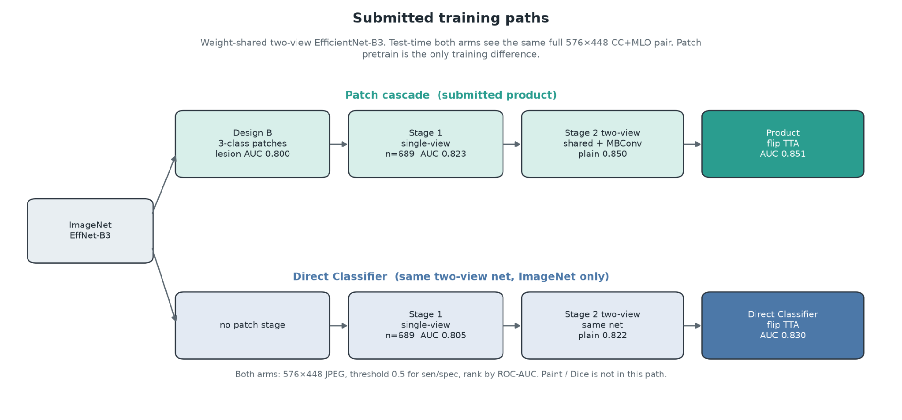
Patch pre-train versus direct classifier pipeline
Data Design and Splits Architecture 5A/B
Single image splits (used by stage 1) consisted of 2,674 training examples, 124 validation samples, and 689 testing examples. The validation split is taken from the pre-defined training split with GroupShuffleSplit on patient ID. Rows without ROI masks are also dropped.
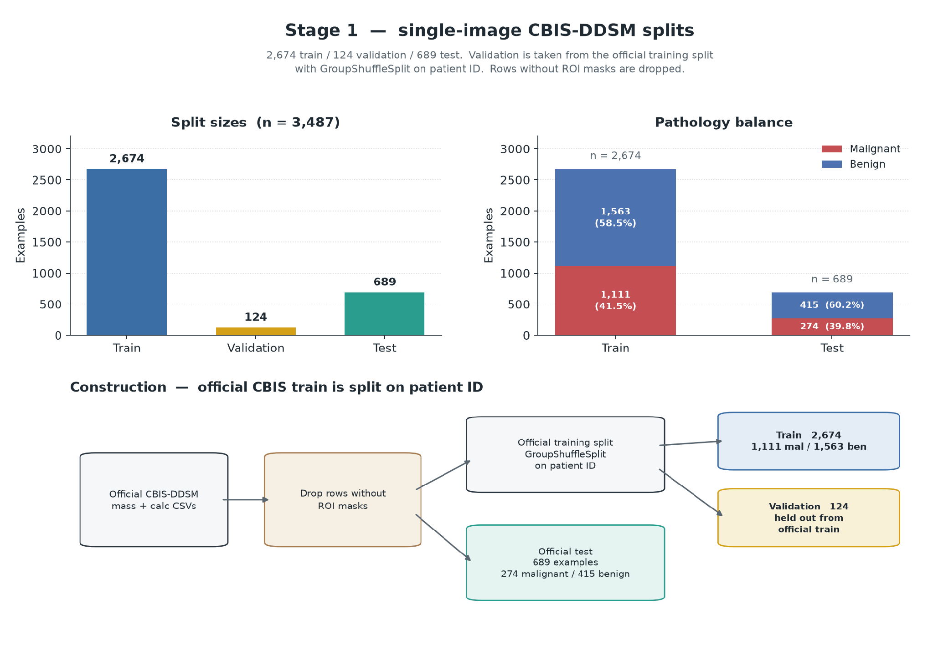
Stage 1 data split breakdown

Moving to the two-view architecture used by stage 2: train examples number 1099, 122 for validation, and 291 testing examples. Mass and calcification CSVs are paired separately, and both views matching patient pathology examples are explicitly required. This led to dropping 532 single view rows. Patient wise validation uses a test size of 10 percent on the official training set, with train pathology at 456 malignant, 643 benign. On the test split it’s 112 malignant, and 179 benign. On a segmentation experiment, the test dataset was further cut down based on presence of masks to 283 total examples, but this was not adopted.
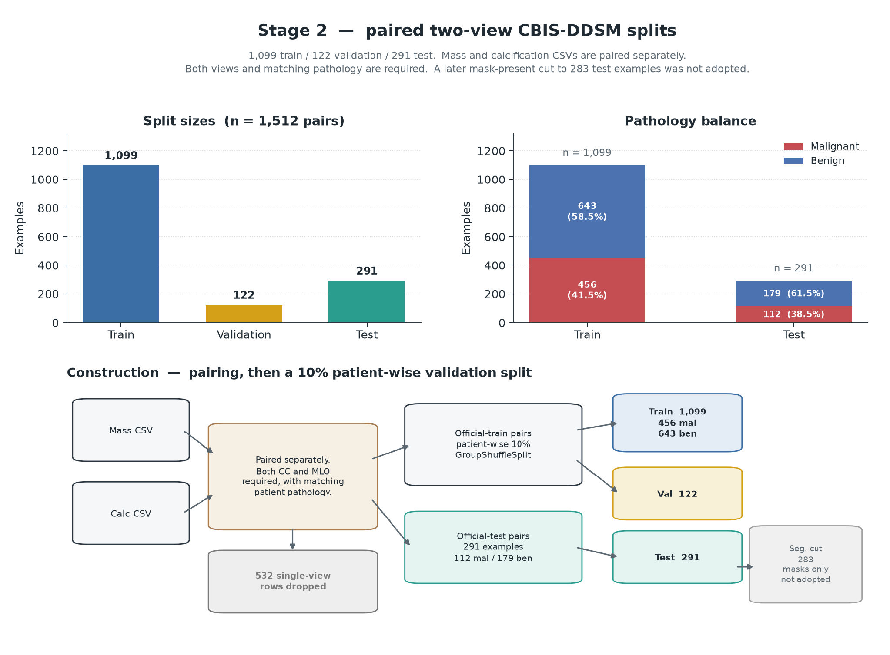
Stage 2 data split breakdown

There is one issue even by using part of the training split as a validation split - is that CBIS-DDSM has patient leakage between the train/test split. Ultimately the train/test split could be refactored such that no set of examples for the same patient would appear both in the train split and test split, but then I wouldn’t be using the official CBIS-DDSM train/test split. Therefore - this project has the same limitations that Wang highlighted in her 2024 review of internal validation.

Architecture 5 Data Pipeline
As established in Wang’s literature review, CBIS-DDSM is one of the more commonly used datasets for deep learning mammography research since it has pathology verified labels, pixel level lesion segmentations, bounding boxes, and modern file formatting (Lee et al. 2017, Wang 2024). Additionally, CBIS-DDSM is available via Kaggle in the format of JPEG images with CSV metadata files (Awsaf 2017).
Additional public datasets such as INbreast, VinDr-Mammo, NL Breast Screen were considered to augment the pipeline, but mixing sources would’ve had additional pre-processing concerns plus it wouldn’t allow closer comparison versus other studies.
The midterm prototype used a tf.data pipeline to serve as both the classification and segmentation heads. Architecture 5 moved to PyTorch and DataLoader objects, which provide prefetch and parallel-map behavior via workprocess, pin_memory, and prefetch_factor. One loader supports both stage 1 and 2 for both variants. Design B doesn’t do this for the patch pre-training though, and instead loads the 300x300 patches before copying into stage 1.

The pipeline is as follows:
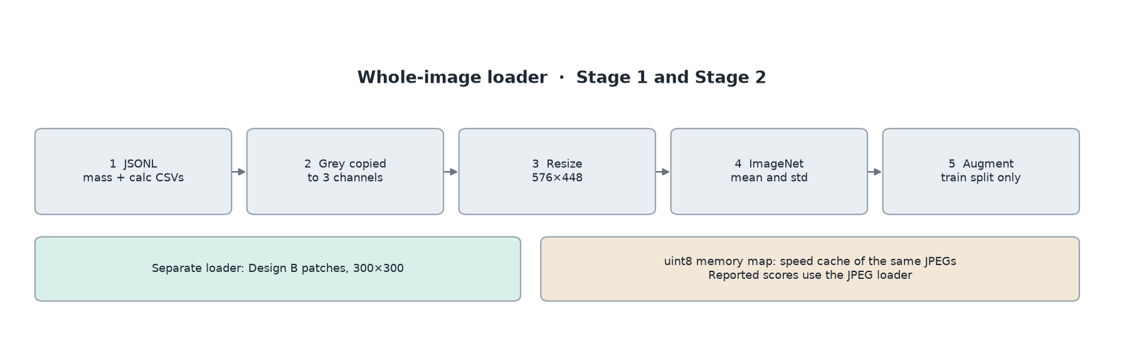
Augmentations are applied pairwise, and include horizontal flipping. The training transformations are a shared horizontal flip when a pair is present to not break laterality versus just transforming one view only. Combination rotation and zoom transformations of 10-15 degrees and 0.85 - 1.15 were also used during a variant of the architecture’s training, but actually didn’t help performance. However - the paired flip is reused at inference during test time augmentation and logits from pre-flip and flipped are averaged to determine the final prediction. TTA is not used during training on the validation set (Tensorflow Augmentation 2024).

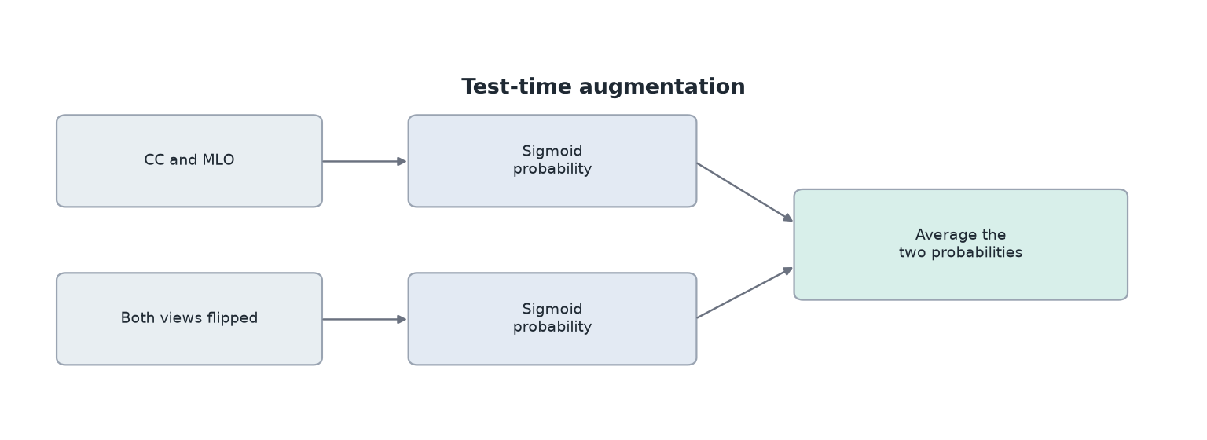
Test time augmentation diagram

Class imbalance will be addressed through calculation of class weights from the training portion. These weights will be passed to model.fit(), and called via the class_weight argument. For architecture 5, it computes the equivalent positive-class weights (benign examples divided vs malignant) and passes it to BCEWithLogitsLoss. The weight is derived from the training split only (Chollet 2018).
Both designs use the CBIS-DDSM train/test split with an 10 percent portioned off the training split as a validation set for hyperparameter tuning and model selection. Splitting logic is done patient by patient using Patient ID, ensuring that the same patient doesn’t appear in both training and validation, but it still doesn’t prevent CBIS-DDSM’s patient leakage between the training set and testing set.
Two filters remove rows before training. Stage 1 drops 81 rows that have no region-of-interest mask, which is useful for design B but ultimately does give design A less to work with. Stage 2 drops 532 single image rows that do not have both CC and MLO views with matching pathology.

Model Architecture Design
As we’ve established earlier, there’s not enough data in the CBIS-DDSM dataset to build a classifier CNN from scratch, but has enough data to finetune upon an ImageNet variant. This approach uses EfficientNet-B3 as per Petrini and Kim’s findings as the best fit for CBIS-DDSM. While Chougrad et al. 2018 reported strong performance with InceptionV3 and VGG16, their approaches weren’t a multi-view approach, nor done on the official split. And in the two Petrini papers, these architectures typically lost performance the larger the input resolution became. EfficientNet-B3 remains competitive even with higher resolution inputs, although doesn’t apply for my approach as I’m using half-resolution JPEGS (Chougrad et al 2018, Petrini and Kim 2025).
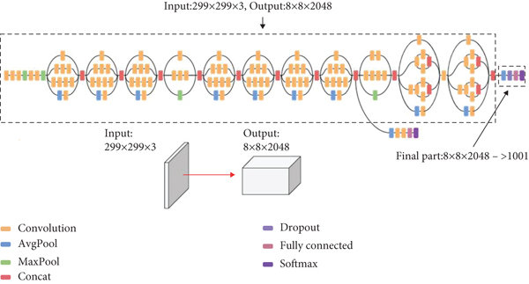
InceptionV3 architecture (Szegedy et al. 2016)
As covered before, both CC and MLO views are utilized via a shared backbone in both design variants very similarly to Petrini and Kim 2025. However, Petrini and Kim test both full and half resolution scans opposed to just half resolution scans, and use three seeds opposed to one. The fusion block, data preprocessing, and patch initialization also differ, so I can’t say that this project is a one-to-one competitor, but is the closest paper to my approach (Petrini and Kim 2025).
Stage 1 for both variants is a single view EfficientNet-B3 initialization. The torch vision feature extractor is followed by global average pooling, and dropout of 0.5, a 256-unit dense layer with ReLU with a dropout of 0.3, and one logit. Both dropout rates were taken from Chollet 2018, and the same rates were also used for the midterm. A sigmoid is applied to the logic only when a probability is required. Training uses BCEWithLogitsLoss on the logit with the positive class weight taken from the training split only.
Stage 2 then calls the same feature extractor on the CC tensor and MLO tensor. The weights are shared, so both views can update one module. Each map has 1536 channels concatenated to 3072 and passes through one MBConv block with an expansion ratio of 2, 3x3 kernel, and stride 1. Pooling and the dense head follow similarly to stage 1, and the first dense layer is sized for the fuzed 3072 channels. The pair then provides one logit. The two images in question are not stacked into a six channel input.
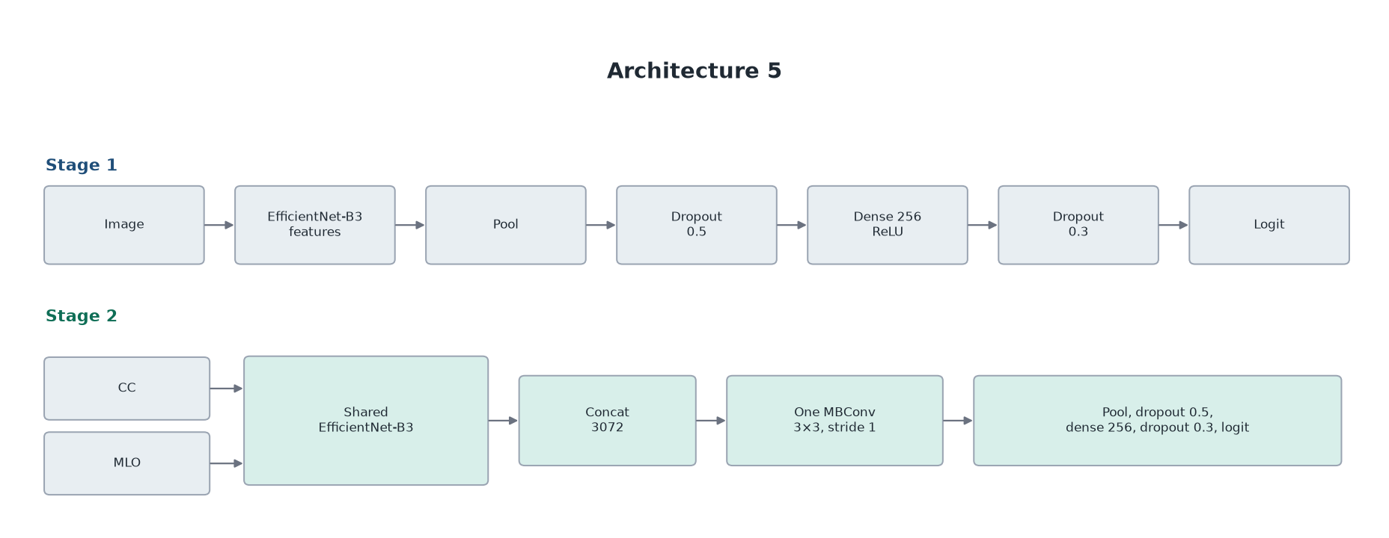
Architecture 5 common pipeline
Design B adds a patch pretrain before stage 1. It trains a three-class head (background, benign, malignant) on 300x300 crops from the full mammogram. A lesion crop is the CBIS-DDSM box expanded by a margin, then padded or downscaled to 300x300. The champion run draws tighter and wider margins around that box. Background crops are taken from outside the mask. The crop is not a sliding window. Only the EfficientNet-B3 backbone is copied into the stage 1 network above and the three-class head is discarded. It is not part of stage 2. The direct classifier skips this step.
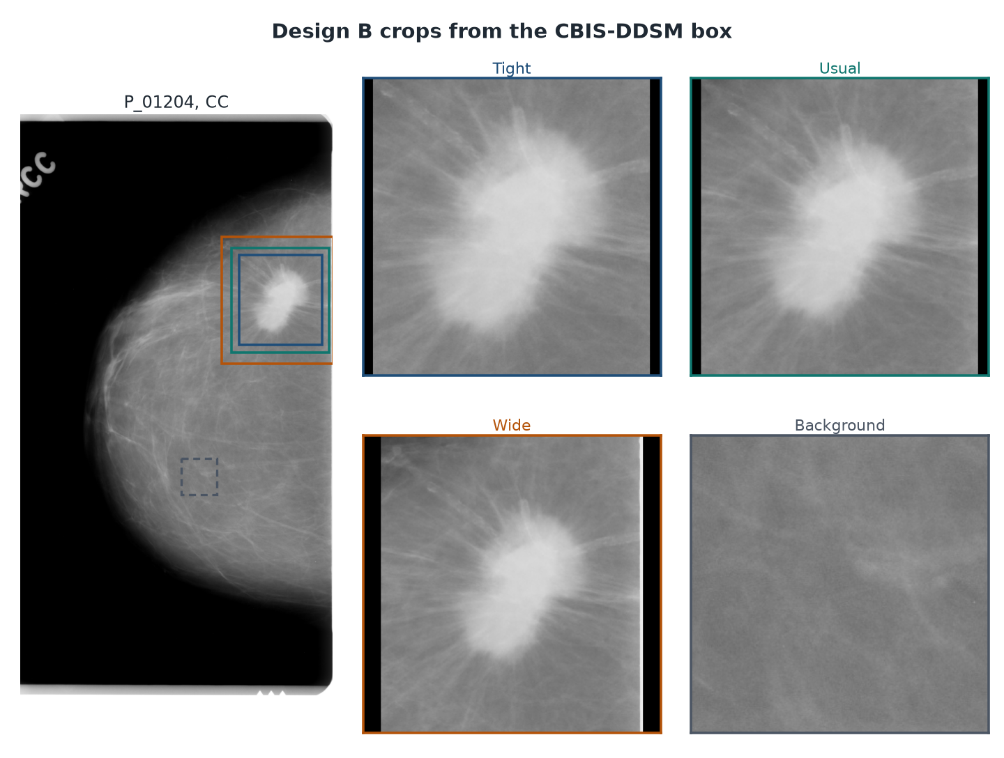
Stage 2 follows Chollet’s freeze-then-fine-tune schedule, and the two arms do not share one timetable. The Direct Classifier freezes the convolutional core in phase 1 and trains the head for 5 epochs at 1e-3. Phase 2 unfreezes the network and fine-tunes for 20 epochs at 3e-5. That phase-2 learning rate, and these phase lengths, were selected in the two-view hyperparameter sweep.
The patch arm trains the head for 12 epochs at 1e-3, then fine-tunes for 8 epochs at 1e-5. Early stopping on validation AUC was enabled, and this run used the full budget. Both Stage 2 runs reached their highest validation AUC in phase 1 - epoch 3 for the Direct Classifier and epoch 7 for the patch arm. Those are the saved checkpoints. The graph below shows the validation curves:

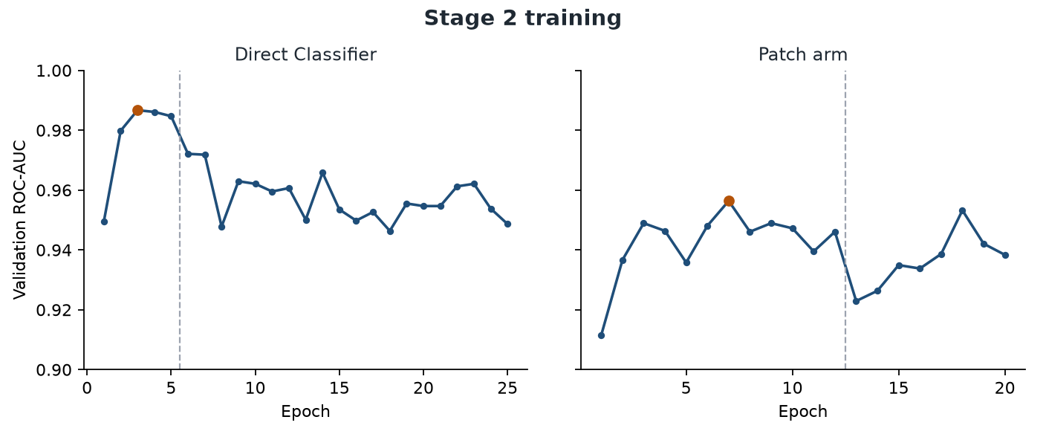
Direct Classifier and Patch Arm Validation AUCs vs epochs

Evaluation Strategy and Metrics
Checkpoints and hyperparameters were determined via the validation split, and the test split was not used to pick the epoch. The validation split consisted of 124 single-image rows and 122 paired exams. The main ranking metric that all models were evaluated against was test ROC-AUC. Other aspects are considered as well, such as accuracy, sensitivity, specificity, precision, and F1 score, but ultimately ROC-AUC was the guiding metric. This did lead to an interesting circumstance however, since the direct classifier actually has a higher accuracy than the patch classifier at an operating point of 0.5 alongside better specificity. I still think it’s worth keeping ROC-AUC as the primary metric since in theory the operating point could be changed at time of theoretical deployment, and ROC-AUC captures performance at multiple operating points. Further details in evaluation/conclusion.

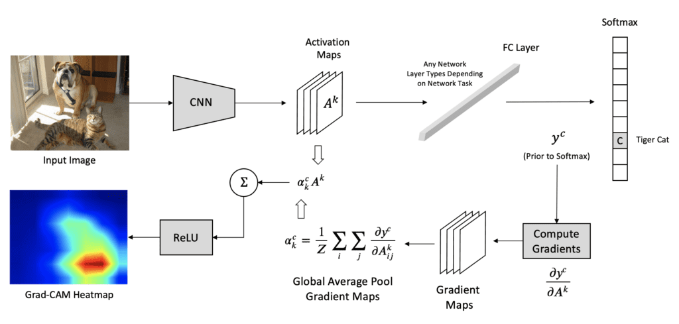
GradCAM Diagram (Kromydas 2023)

Explainability
A segmentation branch was trained on the single image split and was not adopted. For the direct classifier, Grad-CAM was used via the class logit at the last convolution of the shared backbone with one heatmap per view. The heatmap is produced only after the decision. It doesn’t contribute to decision making, and does not make the model accountable. Further details in implementation.

Conclusion for Design
Now that we have the design out of the way, how did both designs practically work? This will be covered in the implementation section.

Implementation
Implementation will cover how the Jupyter notebook that ran this pipeline worked, alongside applicable plots for each section.

Environment
The Jupyter notebook uses a Python virtual environment in WSL2. WSL2 was used since cuda refused to work for me in Windows natively, and so it was better to set up in WSL2 instead. I access the WSL2 instance with Visual Studio, and can also send commands to the terminal with Visual Studio. Main libraries used are PyTorch, torchvision, and scikit-learn. CBIS-DDSM is in the same folder the .venv is in, and is kept in the same folder structure it originally came in.

Midterm Prototype and Attempted Architectures
Before covering Architecture 5A and 5B, I’ll go over all previous architectures tried.
The prototype I submitted for the midterm video + report was a Chollet workflow based on Keras InceptionV3 and VGG16 averaged on both predicted probabilities. Below is a table of the midterm’s performance:

 | Ensemble | InceptionV3 | VGG16
ROC-AUC | 0.751 | 0.704 | 0.717
Sensitivity | 0.517 | 0.599 | 0.503
Specificity | 0.827 | 0.719 | 0.762

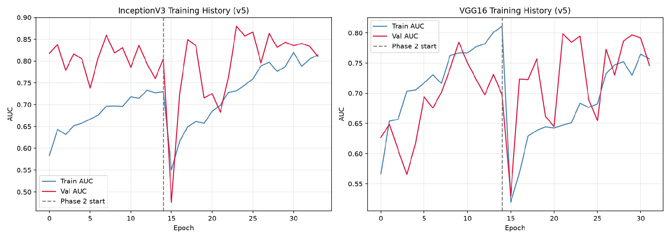
Best version of InceptionV3 and VGG16 training run docs/experiment_results/legacy_cnn/training_history_v5.png
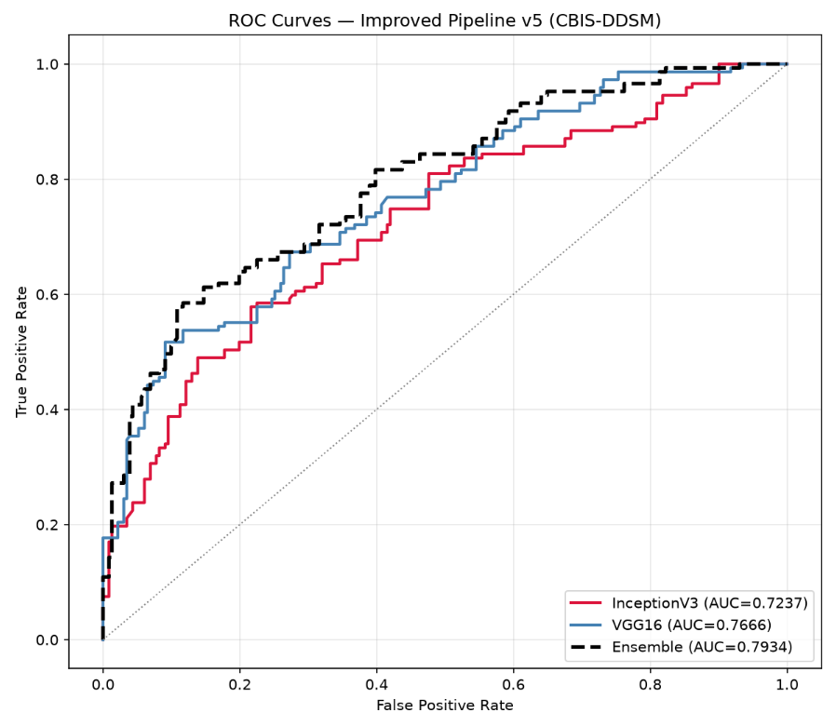
Performance of Midterm Prototype after hyperparameter sweep (0.751 AUC)
This prototype was quickly swapped out after the midterm. Additional details will follow.
Architecture History
Multiple architectures were attempted during this project, totalling six approaches.
Architecture 1 was the midterm prototype previously discussed.
Architecture 2 explored using NVidia’s LocateAnything-3B with instruction tuning. This approach didn’t work very well, as the purpose of the model does not lend itself towards classification performance, but rather exploring images using semantic commands of which this project doesn’t need as the classes are pre-defined. Regardless - I pushed forward by instead taking MoonViT-so-400m as the image classifier backbone and seeing if the model could improve on my previous results. This did not happen - after a hyperparameter grid search, the best result was an AUC of 0.669. This architecture was abandoned quickly.

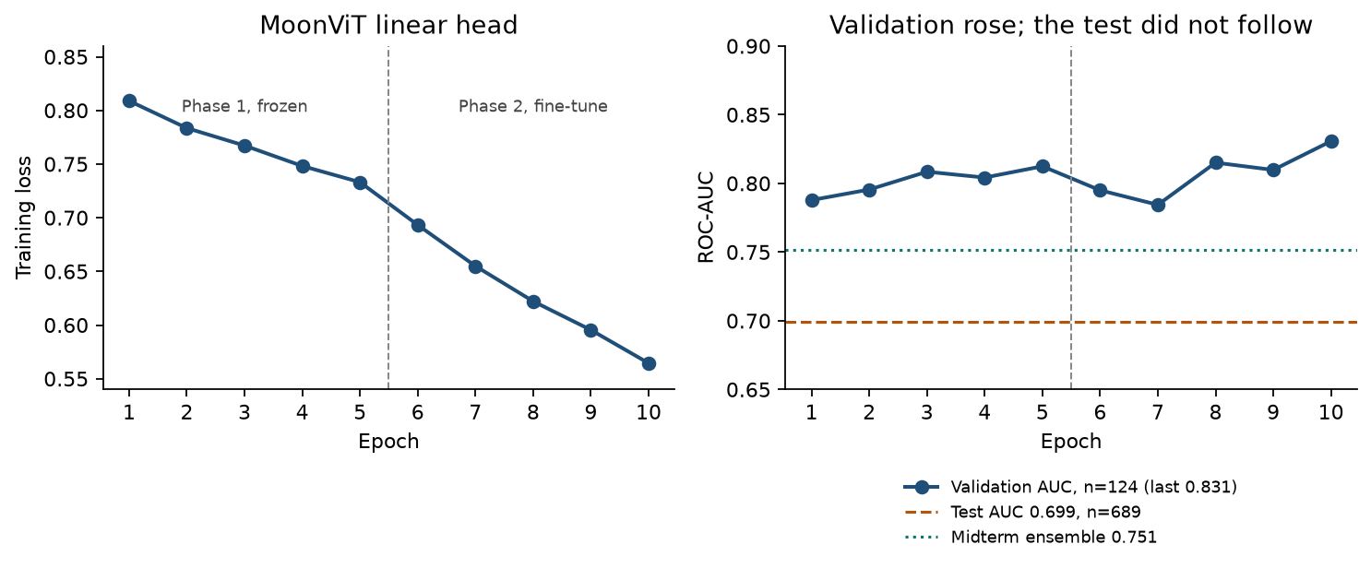
MoonViT-so-400m training loss and validation AUC - test AUC didn’t follow training AUC
Architecture 3 was a cascaded EfficientNetV2 backbone following feeding extracted features into a SwinV2 classifier. Nine configurations were trained, crossing three model sizes with three different regularization settings. On the 689 image test, the best score was achieved with EfficientNetV2-M feeding into SwinV2-Small. It only roughly tied with the midterm ensemble, and so was abandoned quickly.
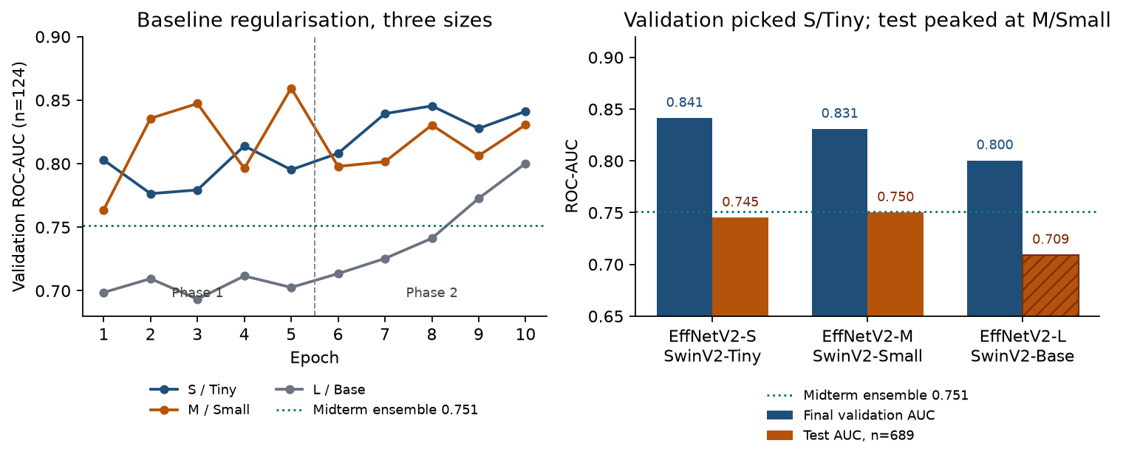
Best performing cascade configuration validation ROC-AUC and test ROC-AUC
Architecture 4 implemented two independent EfficientV2-S towers for a multi-view approach with the feature maps joined via channel level fusion. This isn’t Petrini et al. 2022’s approach where one network is called twice, but I was experimenting to see if independent towers could improve classification performance by building a backbone per view. It didn’t help - and only led to a test AUC of 0.649 on testing pairs. Partial freezing ablations improved performance, but still fell short of the midterm ensemble, and so that motivated architecture 5 to be more in line with Petrini’s approach.
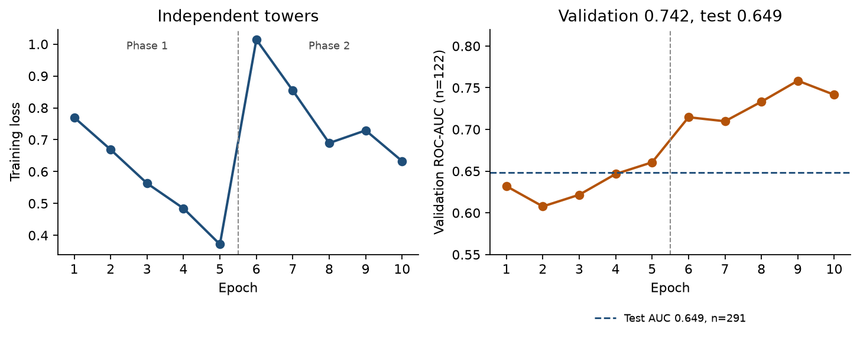
Training loss vs epoch and training AUC and test AUC

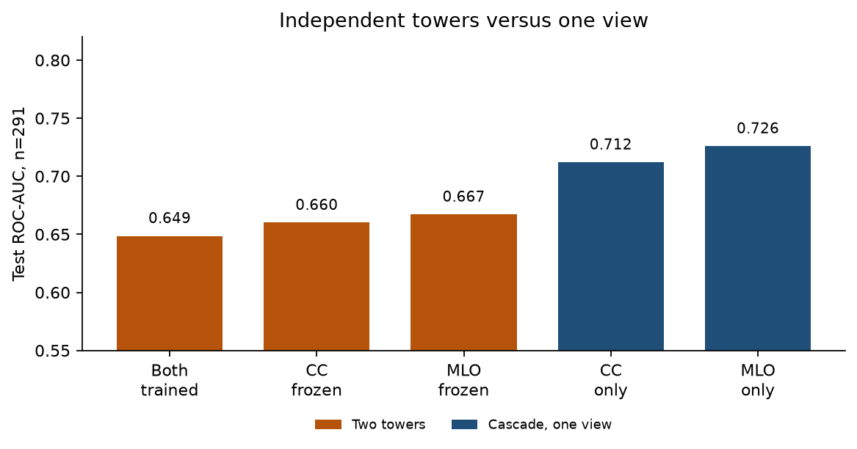
Training loss vs epoch and training AUC and test AUC

Data Preparation
The JSONL split from the midterm were reused. No new random split was drawn, and K-fold validation wasn’t tried. A single image record stores each image path, a binary pathology flag, patient ID, and a mask path if it exists. Pairing is done separately inside the mass table and inside the calcification table. A pair is the CC and MLO view of the same case, and the pathology strings have to match to be valid. The validation cut inside the official training set is a GroupShuffleSplit on patient ID, 10 percent, with a fixed seed for reproducibility. This doesn’t prevent the patient leakage already in the official train/test split.
Stage 2 returns the pair with one exam-level label, so the loss comprises of one logit per exam. The loader pins CUDA memory with a uint8 memory map with a metadata JSON, and caches the JPEGs. This sped up training time considerably. The patch classifier uses a different loader. A lesion crop is the CBIS-DDSM box expanded by a margin and then padded or downscaled to 300x300. A background crop is a random 300x300 window whose overlap with the mask is at most 0.05, with 40 attempts. Only the backbone is copied into stage 1, with the three class head discarded.

Loader diagram

Shared Two View
The main classifier class is SharedTwoViewClassifier. The constructor loads torchvision EfficientNet-B3 with ImageNet weights when the pretrained flag equals True, and then keeps only the convolutional features as self.shared_core =eff.features. That is the direct classifier. The patch arm builds the same class with pretrained = false, then copies the design b backbone into stage 1 and that stage 1 checkpoint into stage 2. In both cases the stock ImageNet head is discarded. The three class patch head is discarded as well, and doesn’t share parameters with the exam head. Both views use the one module, so each training step updates the same convolutions.
Architecture 5 stack
The forwarding method takes two tensors (cc_pixel_values and mlo_pixel_values) with the shape tensor (B, 3, H, W). Both are passed through self.shared_core, or torch.utils.checkpoint for memory. The feature maps are concatenated along the channel dimension to form a 3072 channel tensor. That tensor is then refined by one or more MBConv blocks with expand_ratio set to 2, in 3 by 3 kernels, and with a stride of 1 to preserve spatial resolution during fuzing. Global adaptive pooling collapses the spatial dimensions to a 3072 dimensional vector, which then passes through a dropout layer. The final yield after a few additional layers yields one single logit, and the actual probability that logit translates to is only obtained at prediction time. For training, the logits are used directly to calculate BCEWithLogitsLoss to preserve numerical stability (PyTorch BCEWithLogits Loss, TorchVision EfficientNet, TorchVision EfficientNet kwargs).
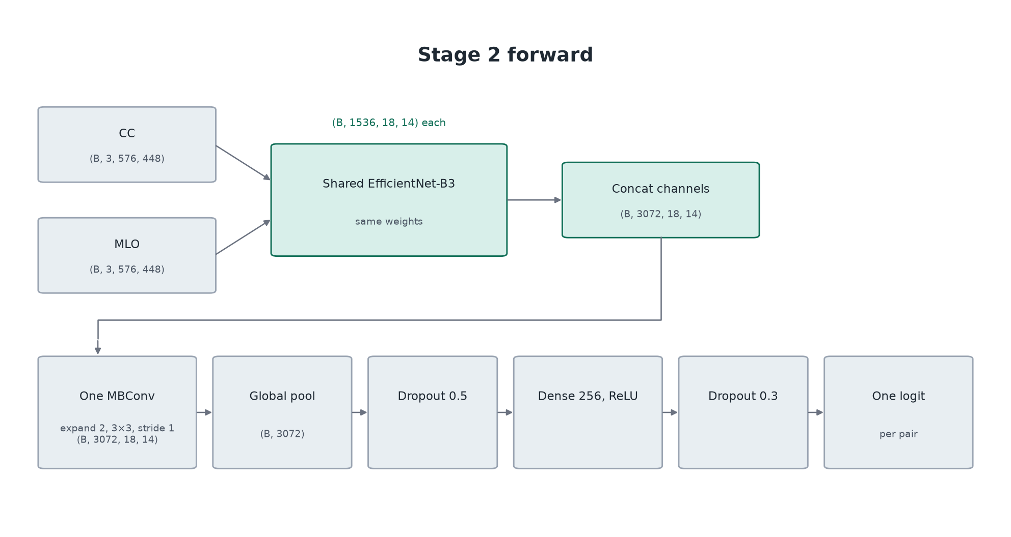
Stage 2 forward pass
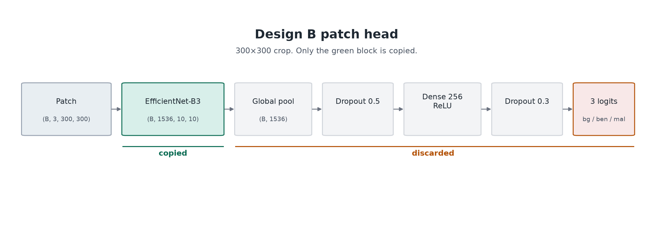
Patch head discarding

Loss, Class Imbalance, and Training Loop Shared
The label is set before training using the pathology string. The same rule is applied for training, validation, and testing. Malignant is 1, and benign (including benign-without-callback) is 0. BI-RADS assessment isn’t used here, and breast density isn’t used either. Petrini and Kim use the same pathology labeling collapse on CBIS-DDSM, and BI-RADS and density can be used to slice the results afterwards (Petrini and Kim 2025).
Training uses BCEWithLogitsLoss with a positive class equal to the number of benign training examples divided by the number of malignant ones. For Stage 2 that is 643 / 456. The optimizer is AdamW with a weight decay of 0.01. Each phase is partitioned by function. Phase 1 sets requires_grad false on the backbone. Phase 2 sets it to true and fine-tunes end to end. Gradients are accumulated in mini-batches and stepped in mixed-precision. After each epoch the model is set to eval under torch.no_grad() and scikit-learn computes validation ROC-AUC for the epoch. Loss and AUC are appended to a history.jsonl.
Augmentation is applied only on the training loader. A paired horizontal flip, applied to both views, is the only transform kept and also the test-time flip. Rotations of up to 15 degrees and zoom between 0.85 and 1.15 were tried but overall hurt validation AUC and testing AUC and so were discarded. Instead, photometric augmentation involving brightness, contrast, and gamma are modified by 0.8 to 1.2 with a probability of 0.5, and contrast limited adaptive histogram equalization with a probability of 0.3 are used with the flip
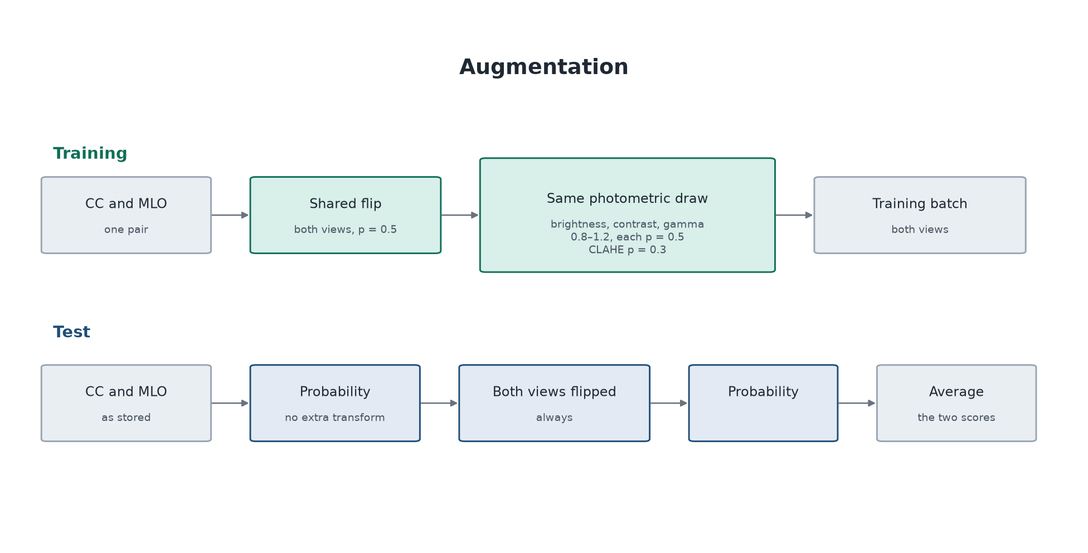
Training augmentation and test time augmentation
Checkpoint Selection and Test Time Augmentation
Checkpointing works via using the best validation AUC across phase 1 and phase 2. A better validation score found during the run replaces best_val.pt by writing a temporary file and then replacing the old file. This prevents a mid-run crash destroying the run’s progress. Therefore, this loop also saves the best AUCs as they come in. The current state is held under a temporary file called last.pt and is updated every epoch. At the end of a run, both last-epoch and best_val weights are evaluated versus the test set. Both designs use the best_val weights from its run, since the validation AUC peaked during phase 1.
Test time evaluation is running the model on the pair of images with a flipped version of those images. The extracted probabilities are averaged, and the resulting AUC is derived from those probabilities. This raised the AUC in the direct classifier from 0.822 to 0.830, and the patch classifier moves from 0.850 to 0.851.
Test time augmentation diagram

Inference and GradCAM
At test time both designs do the same thing. The full CC and MLO views are normalized with ImageNet constants, resized to 576x448, and passed through the SharedTwoView model. One sigmoid is applied to one logit, with no crop, patch head, or box per view.
Grad-CAM was only kept for demonstration purposes and is not used as an explanation for the model. The demonstration maps were taken from the last convolution of shared_core before the two views are concatenated with one map per view on the direct classifier demonstration.

Notebook Structure Diagram
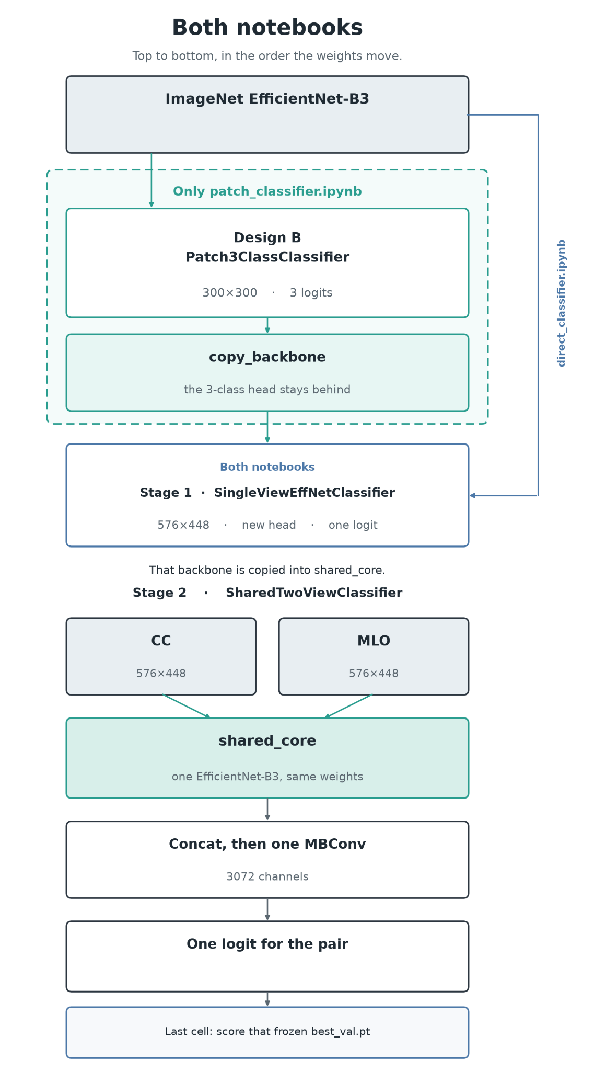
Additionally - here’s the structure of the notebook used to generate cases for the demo kiosk
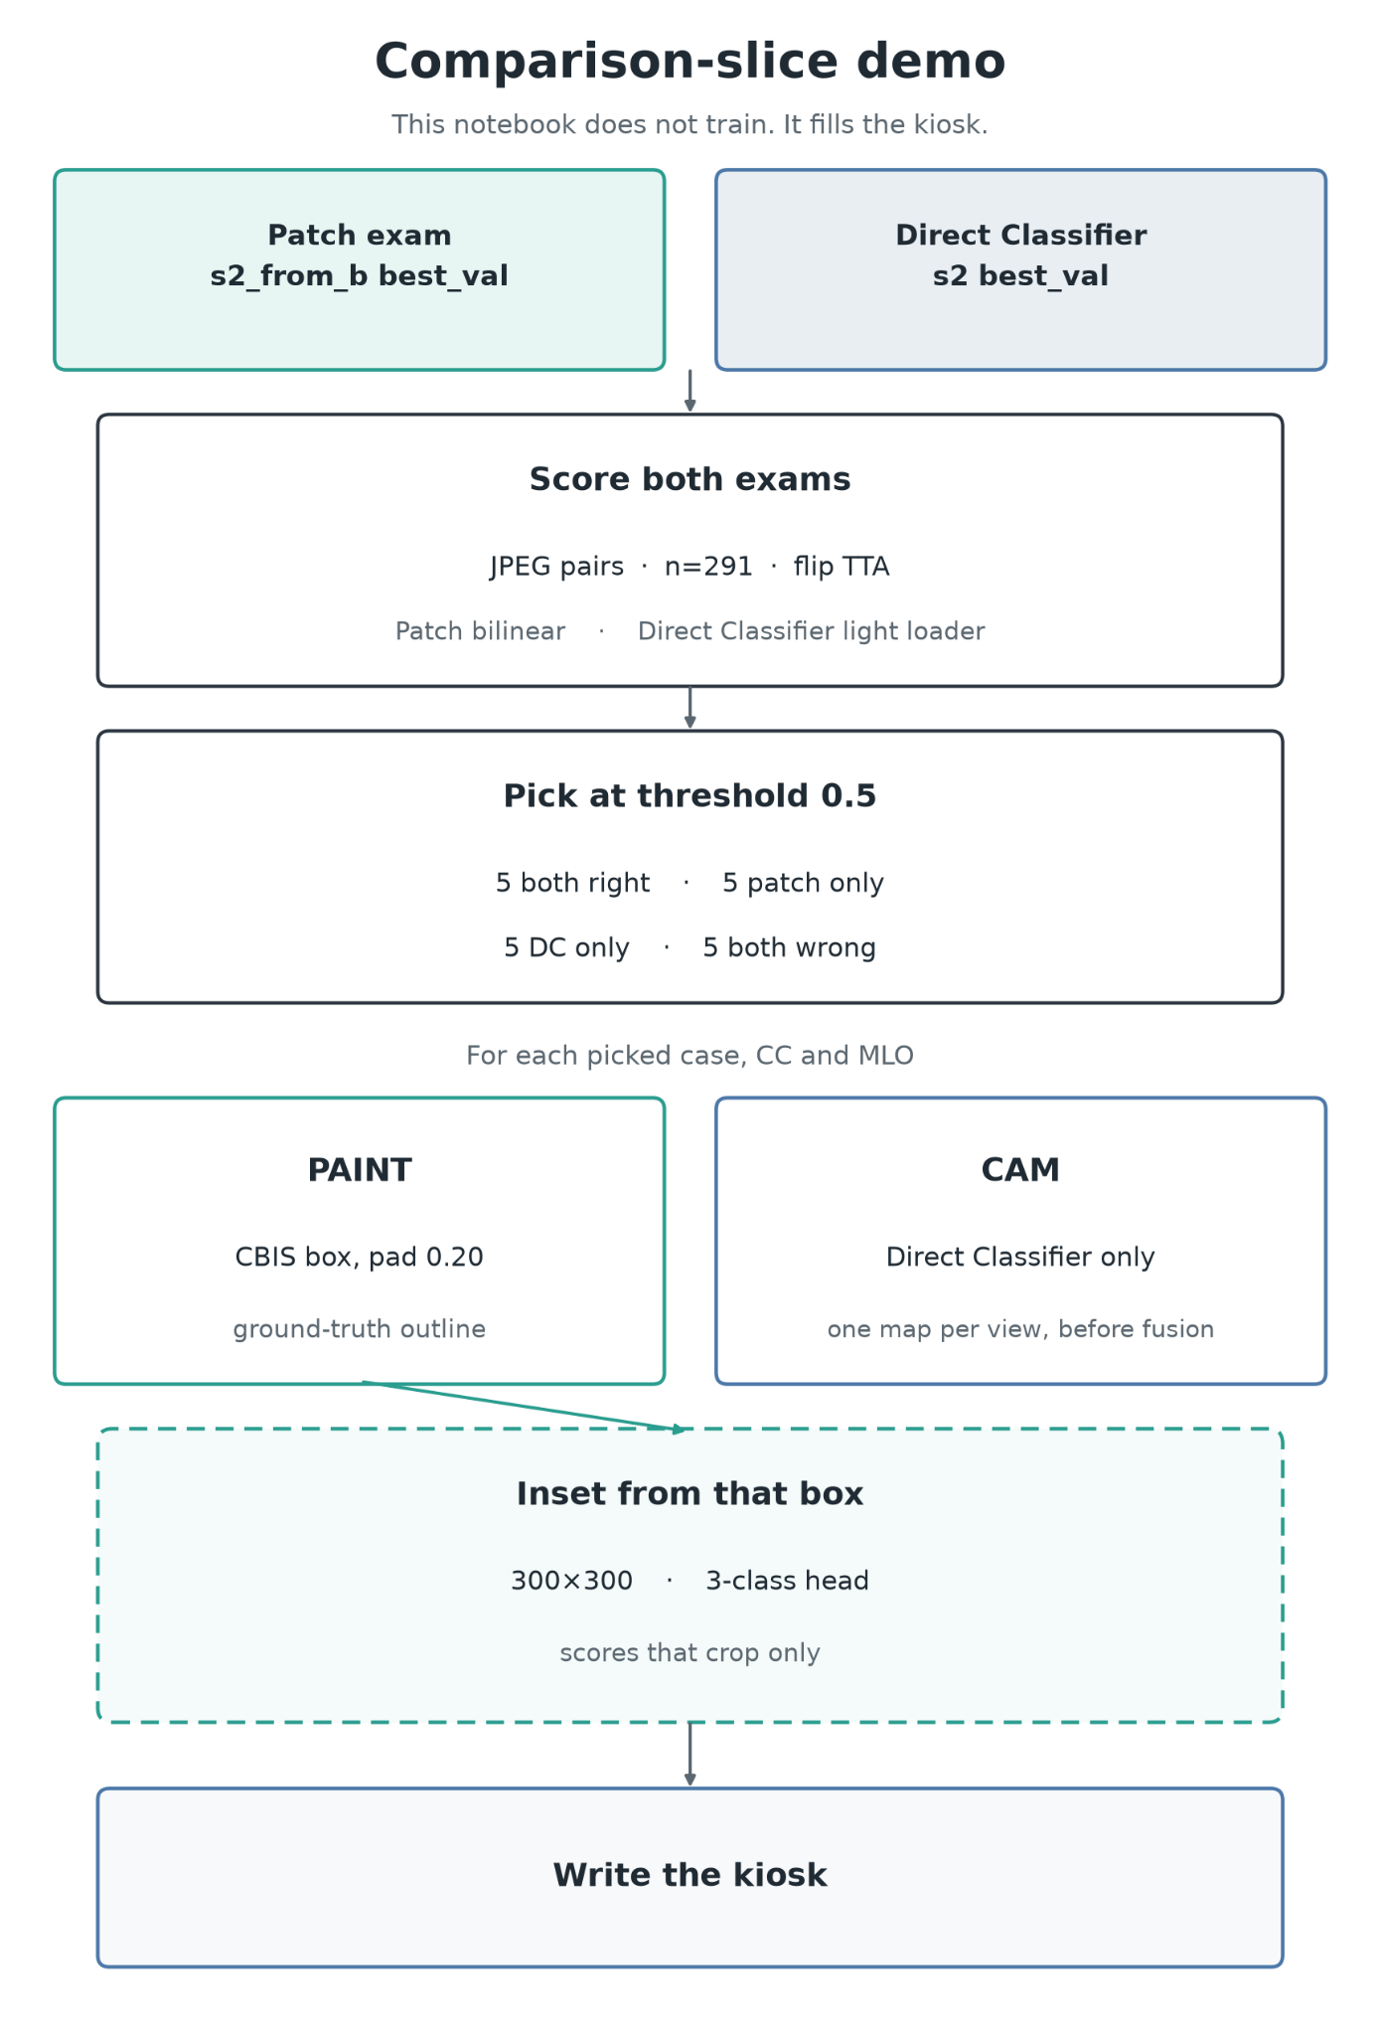

Evaluation
In this next section we’ll go over how well both designs did and attempt to compare them to examples found in Wang 2024’s review and with Petrini and Kim 2025.
The winning two-view result is the top bar, the half-resolution patch classifier with horizontal flip TTA with an ROC-AUC of 0.851. The second bar is the direct classifier.
Petrini and Kim 2025 are the brown bars with their published Hanley-McNeil error as the whiskers. Their two-view rows use the full resolution CBIS-DDSM scans with three training seeds, and this project’s single seed patch bar sits in line with Petrini and Kim’s two-view patch bar. The direct classifier is half their resolution similar to the patch model. Its bar roughly lines up with their single view full resolution direct classifier despite two views helping every time in their paper. However, my project and Petrini and Kim are not directly comparable. Further details in conclusion.
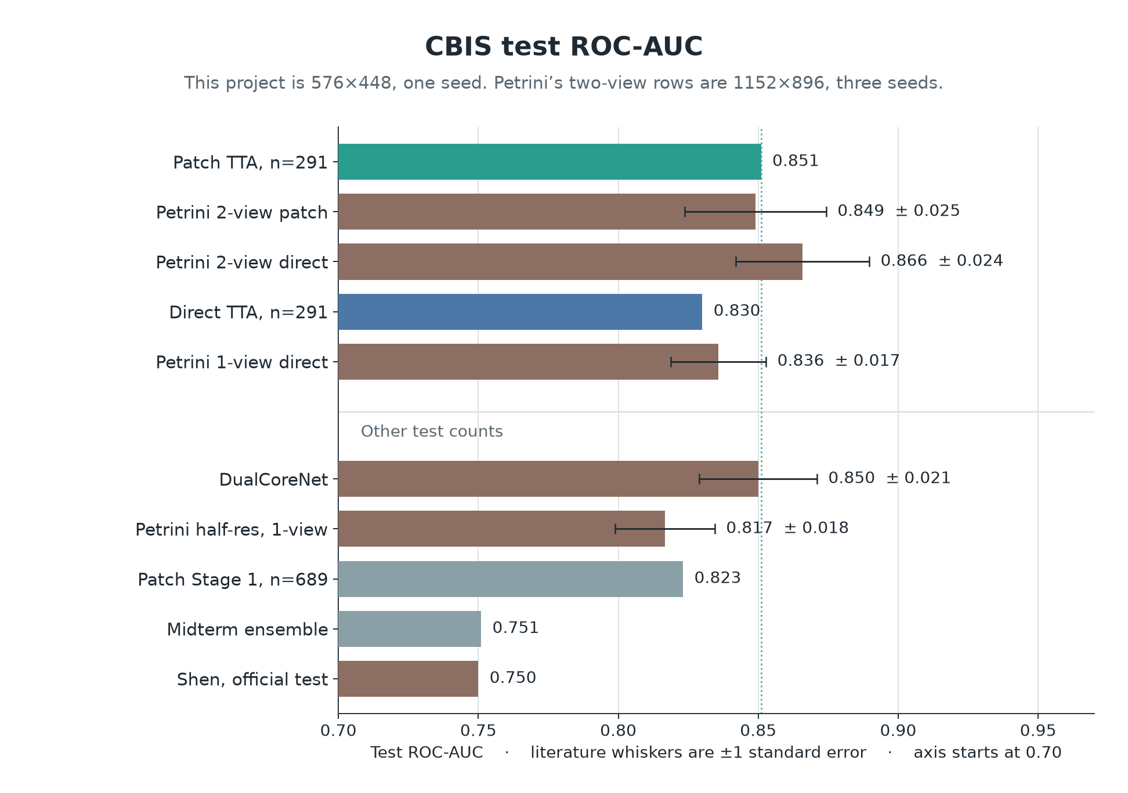
Comparison graph of test ROC-AUCs with published Hanley-McNeil errors included

Both Designs Performance in Detail
This first set of matrixes uses the same horizontal flip TTA and a threshold of 0.5 on all test pairs. The patch arm is able to classify most true malignant cases, but does so at the cost of classifying several benign cases as malignant. The direct classifier does the opposite, where most true benign cases are classified correctly but also puts true several malignant cases as benign.
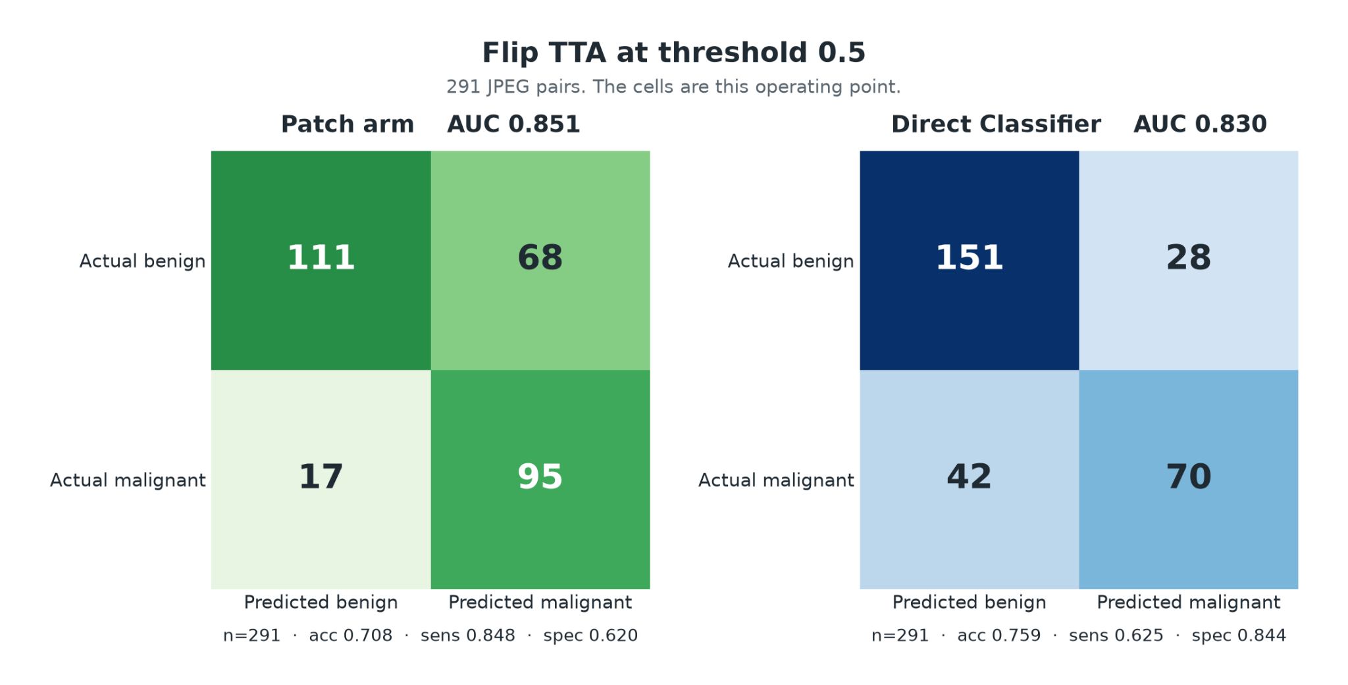

On the upper half of breast density (density 3 and 4) where both normal radiologists doing mammography and CNNs struggle, the difference is exaggerated even further. The patch arm benign row is divided almost evenly between correct and incorrect guesses. The malignant row still sits mostly on the right, which does provide a real sensitivity advantage for the patch classifier. The direct classifier’s benign row is mostly on the left, and the malignant row is split. Both designs are at an operating point of 0.5.

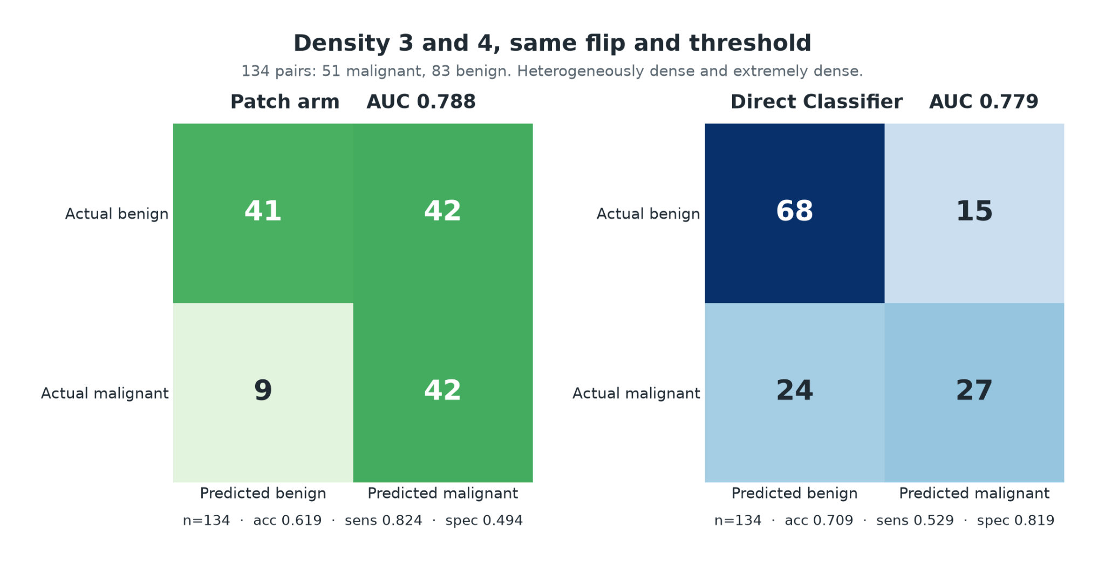

And for additional consideration, at what operating points are both models most accurate and have the best F1 score for all breast densities? For the patch model, which is eager to classify malignant cases, a higher operating point of 0.731 improves its overall accuracy. And conversely for the direct classifier, a lower operating point of 0.225 helps it catch more cases when it should.

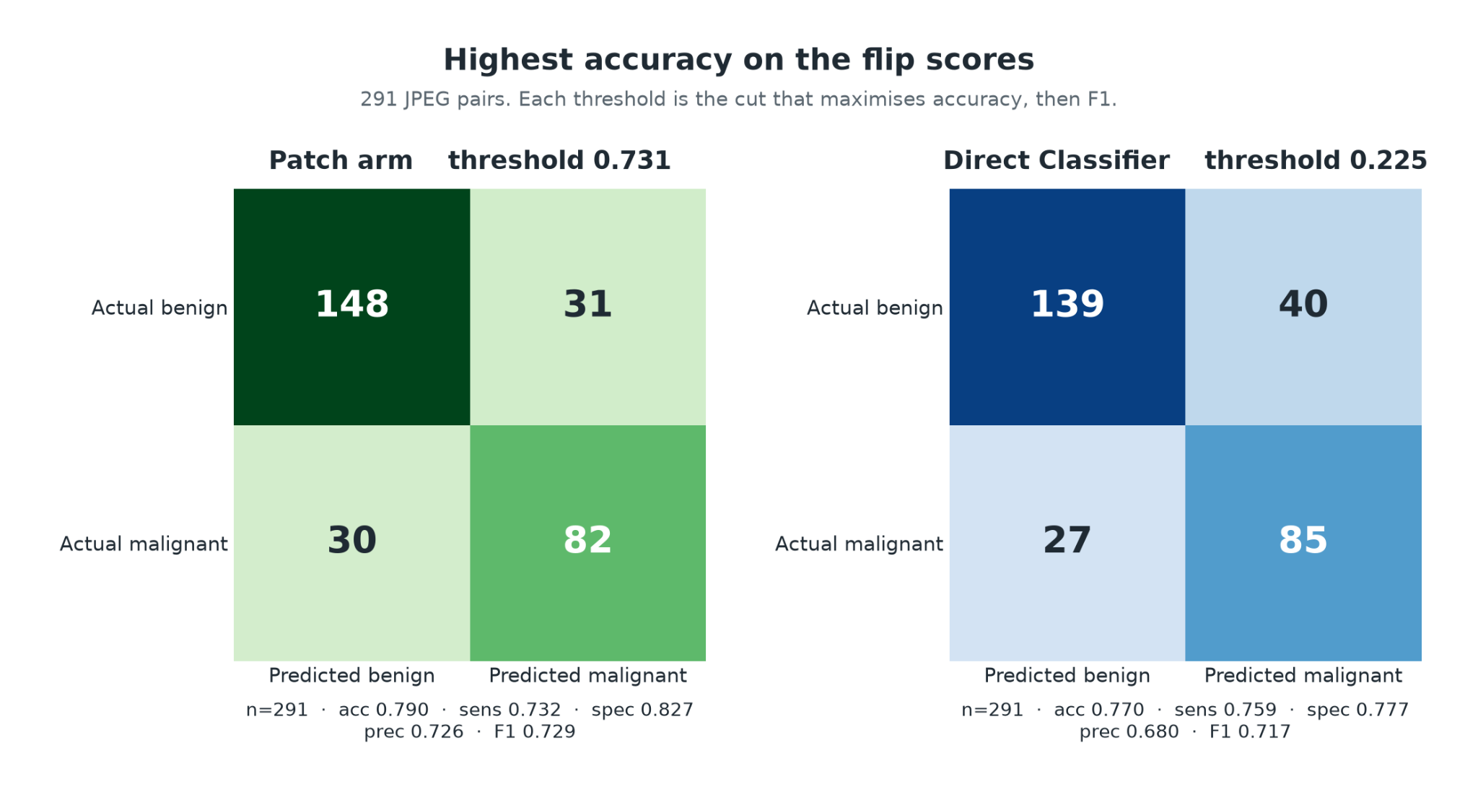
And for best accuracy on the upper half of density, the best operating point for the patch model moves up even more to 0.894 while the direct classifier stays the same. Sensitivity does collapse in the patch design though, but specificity ends up increasing.
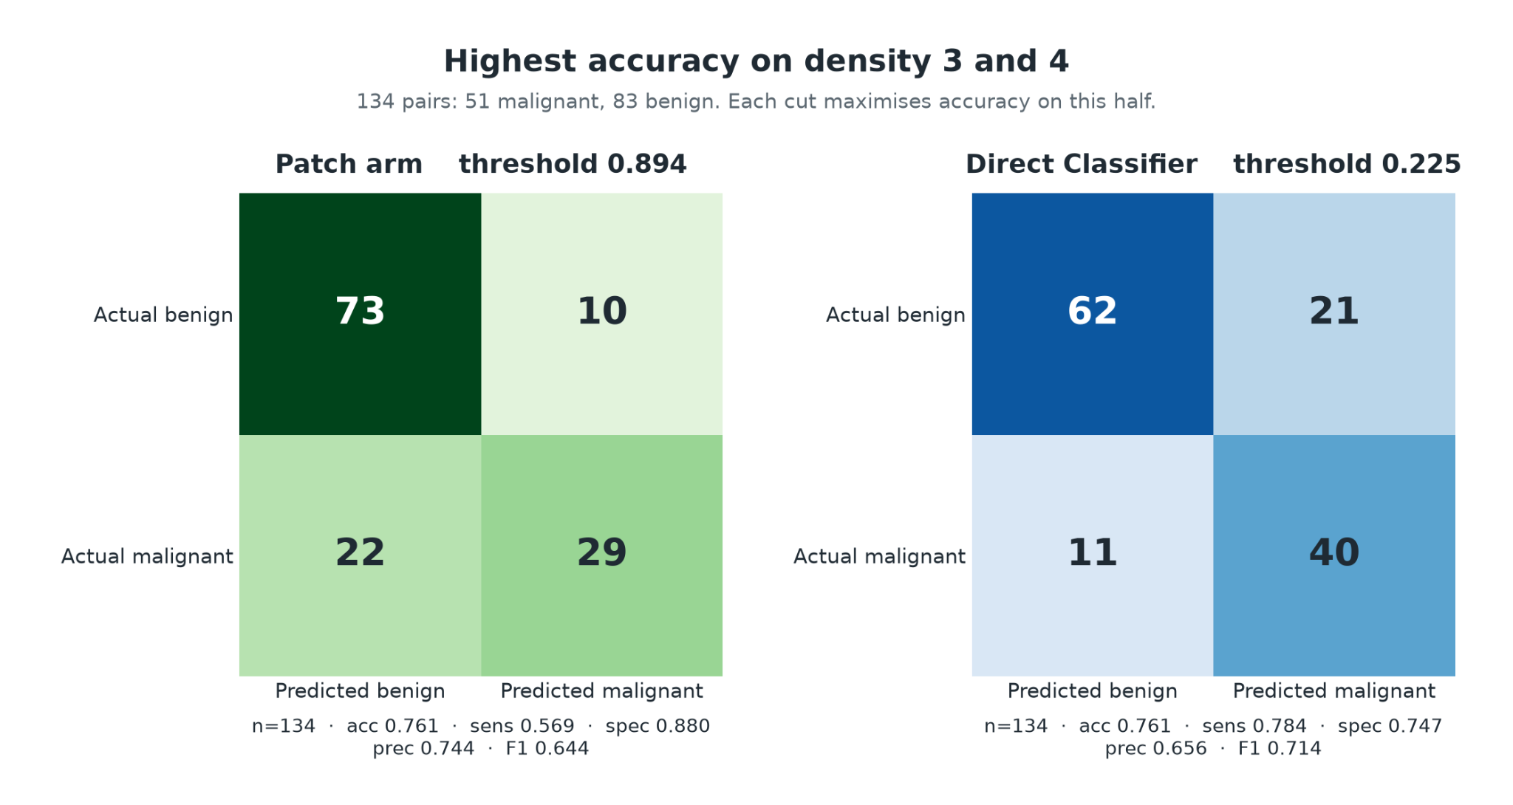

And here are numbers for each model at its operating point optimizing for best accuracy. The operating points chosen also have the best F1 scores as well.
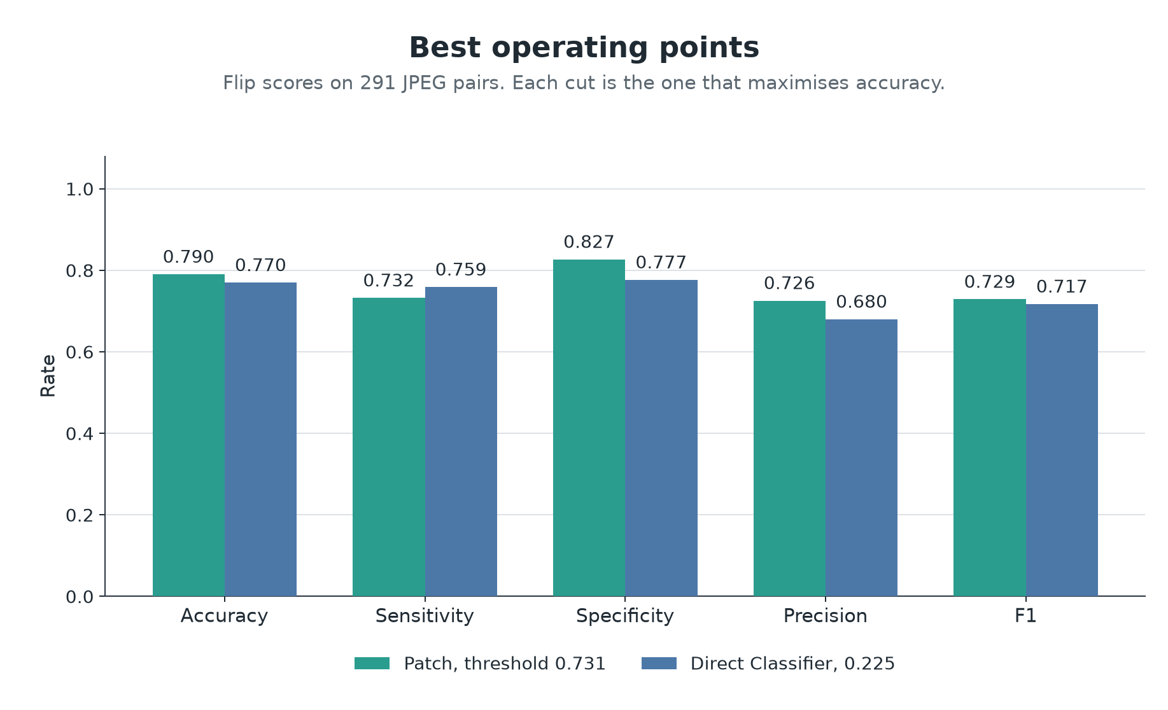

Metrics at best accuracy per design all test cases

Below is a confusion matrix concerning the design b patch head for the three-class network trained on the 300x300 crops before stage 1. This head is discarded, so the matrix isn’t representative of the reported AUCs at test time.
On the 1378 test patches used, the background row does well. The main mistakes made are on the lesion rows, where the head sometimes has trouble deciding between benign or malignant.

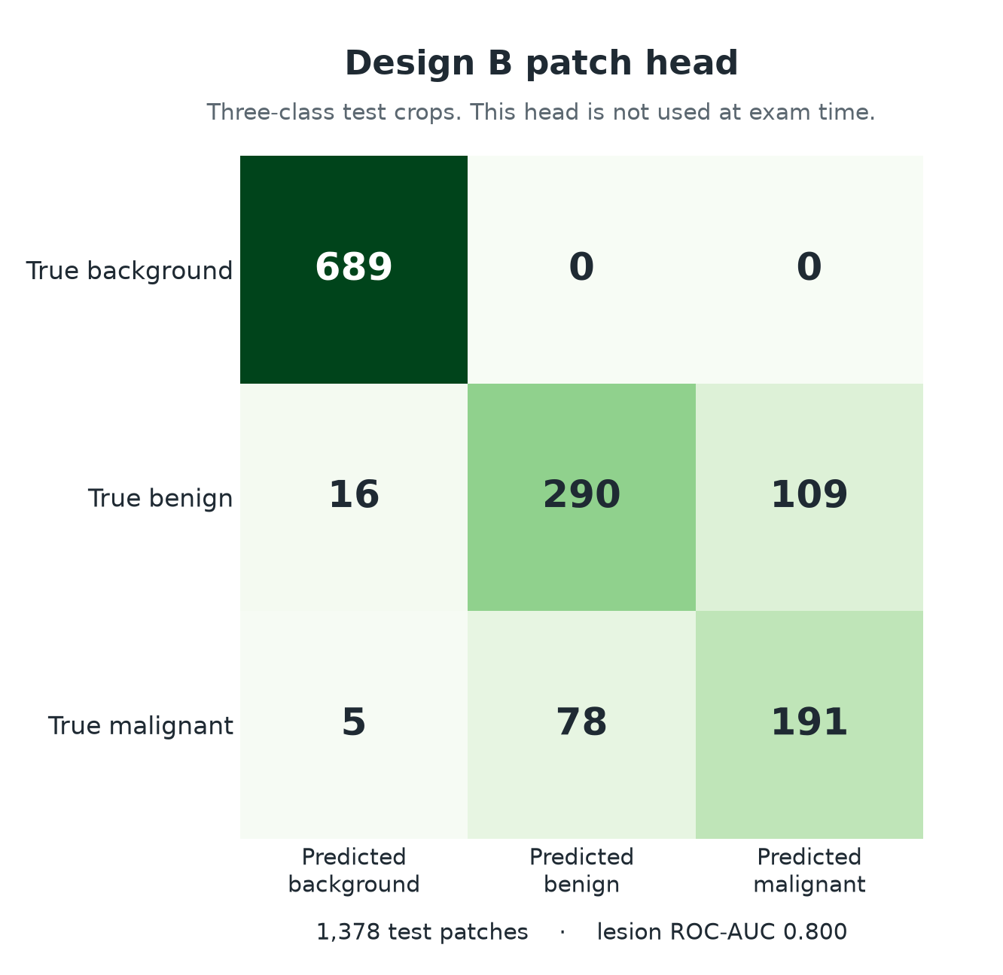

And finally - here’s a snapshot of how the Grad-CAM looks versus the actual annotated ROIs. Both current designs didn’t explicitly train to paint out regions of interest, especially since the patch head gets discarded, but it was an attempt to provide some level of explainability to the model.
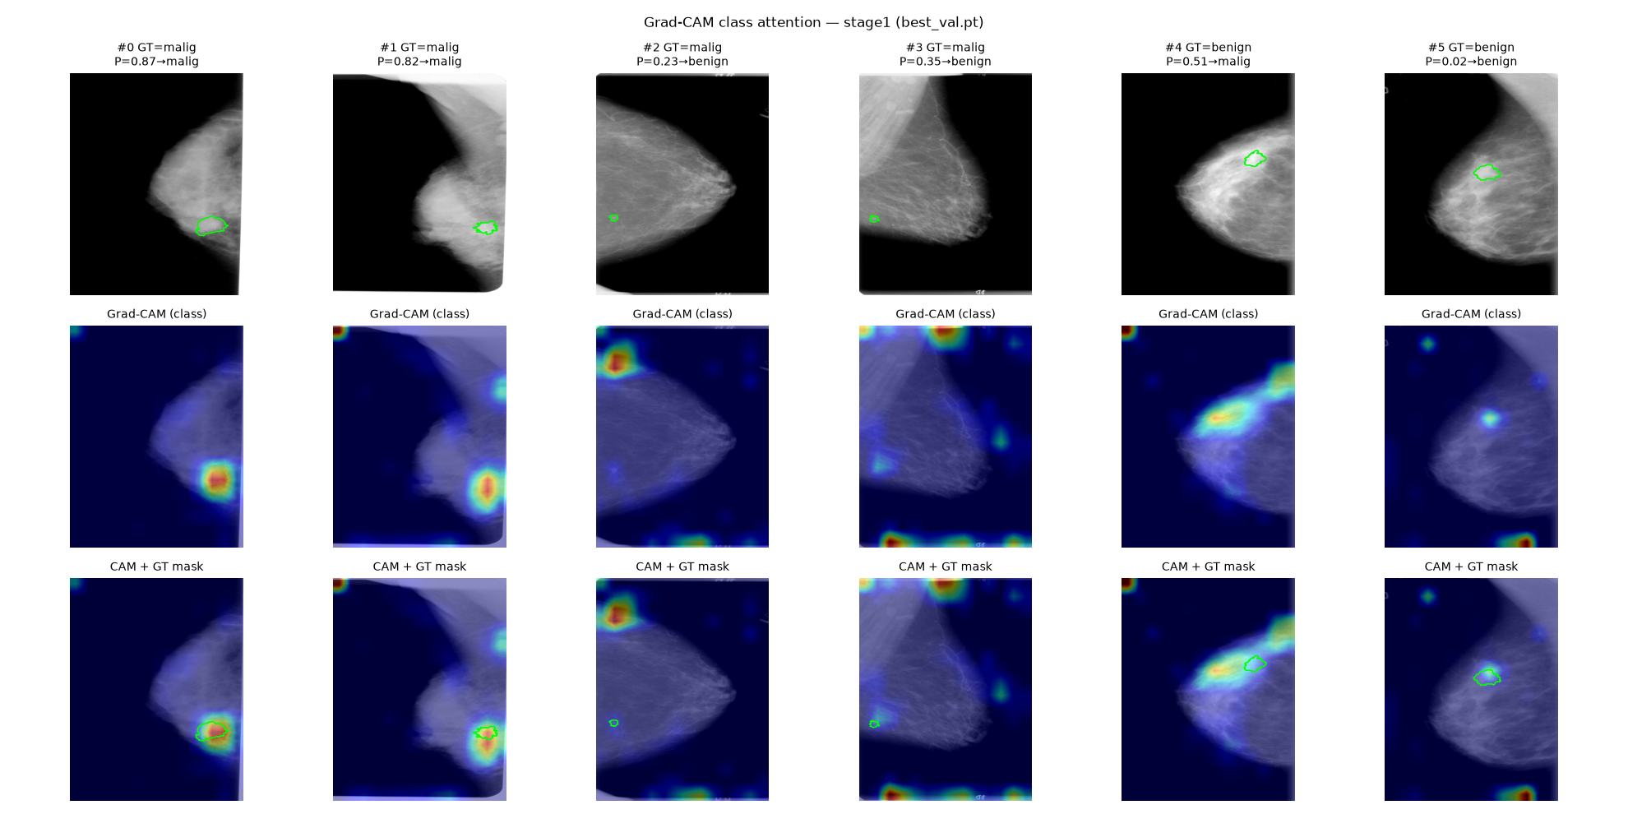

With findings of the model performance out of the way, what’s the conclusion?

Conclusion

Can this project be compared versus other studies?
I’ll compare this project to Petrini and Kim 2025. Both studies use CBIS-DDSM, although this project didn’t touch on VinDr-Mammo. Both start from EfficientNet B3, train a single view classifier, and then a two view model that reuses weights between the CC and MLO views, and then also compare between a patch pre-train and the direct classifier. Both studies use ROC-AUC as the main metric, with horizontal flipping as test time augmentation. And since both studies use the CBIS-DDSM train/test split, both studies are subject to the dataset’s inherent patient leakage.
However - both projects don’t really line up perfectly. Petrini and Kim’s headline two view pipelines are full resolution and the network is trained three times versus this project’s one. They treat the test split as 645 single images while this project fixed the test split as 291 paired images. Their patch classifier has five classes, separating calcifications from masses, but this project only has three (background, benign, malignant). They’ve also published their ROC-AUC with Hanley-McNeil errors, and this project did not. They also didn’t publish sensitivity or specificity, so the thresholds chosen in this project don't have a clean point of comparison.
As it stands, both projects aren’t directly comparable.

Could this project be theoretically deployed?
Lehman et al. 2017 measured routine digital screening mammography in the US through the Breast Cancer Surveillance Consortium. The examinations run from 2007 through 2013. This consisted of 1, 682, 504 screens across 792, 808 women, read by 359 radiologists at 95 facilities. Outcomes were scored with BI-RADS, and the means below were sensitivity and specificity against cancers found on follow-up.

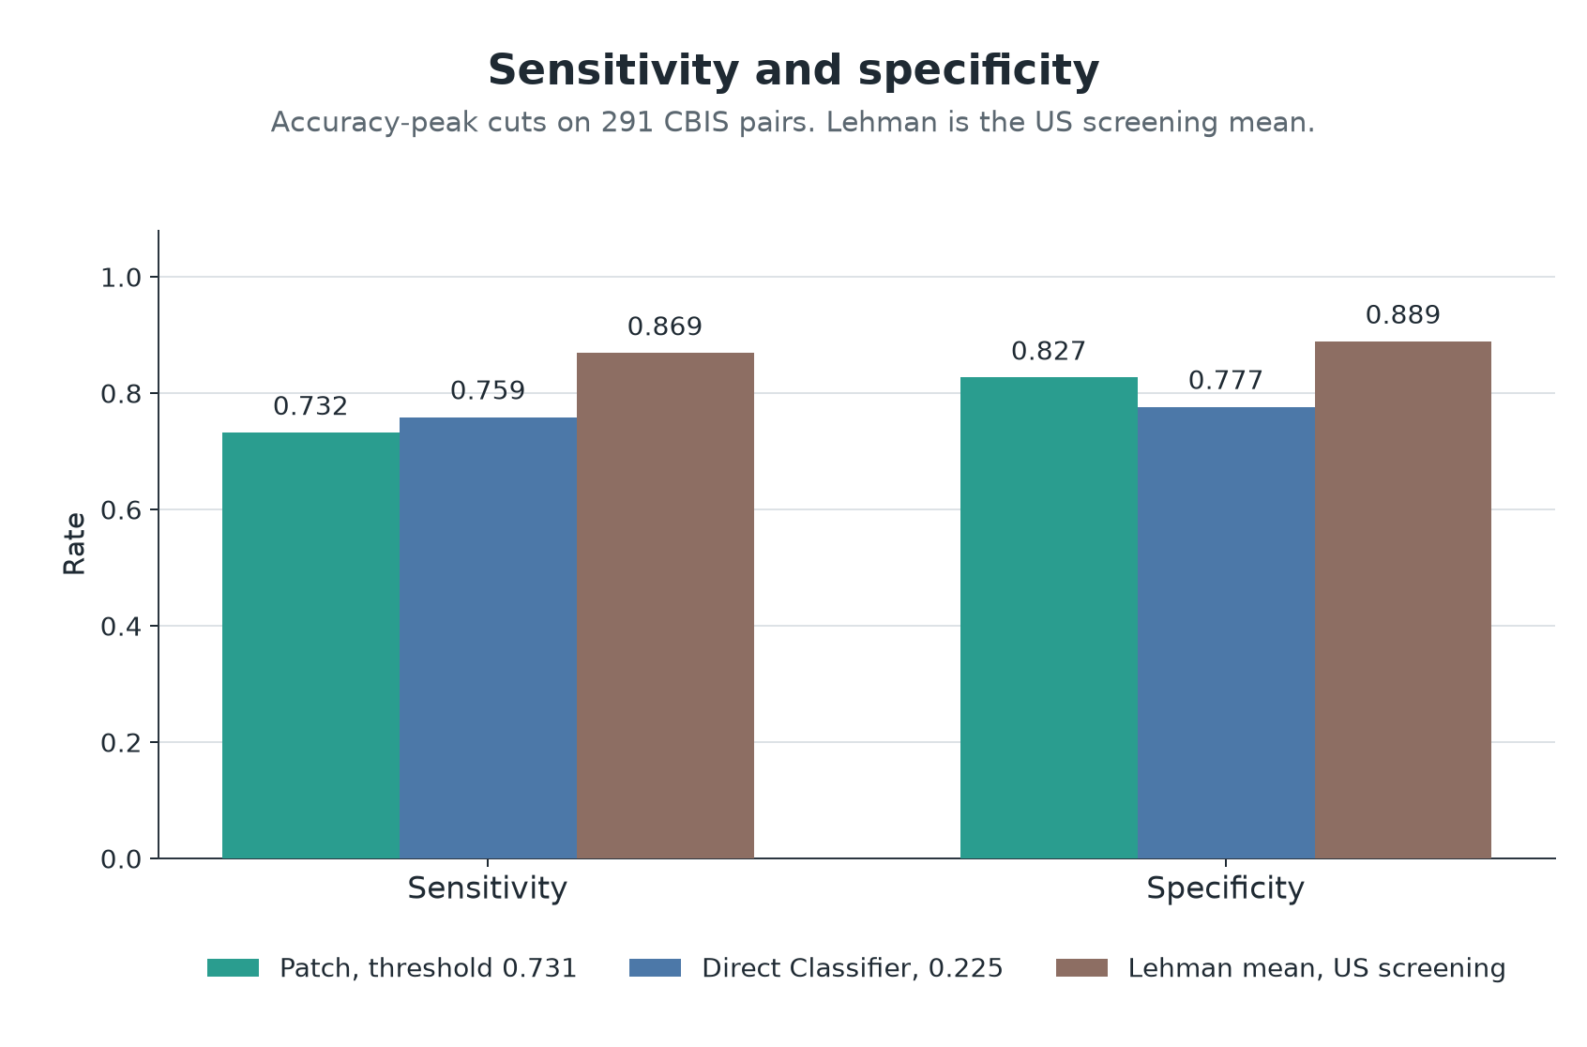
Sensitivity and specificity at highest-accuracy cuts vs Lehman study means
The Lehman figures were found through routine digital screening, with approx. six cancers per thousand examinations. The paired test split in CBIS-DDSM are ~ 2 cancers per 5 pairs. While testing and evaluation conditions are different, arguably the CBIS-DDSM dataset is easier to push measured performance on due to the patient leakage, and this project still doesn’t exceed an average radiologist’s sensitivity or specificity when roughly compared like this. The bars are the cuts at 0.731 and 0.225, found by searching these test labels. At the pre-set threshold of 0.5 the patch arm’s sensitivity is higher than the bar on this chart. Overall however - I’d say no, this project can’t be deployed as is.

What would a better project look like?
I would keep this exam network and then tighten the evidence around it. The official paired test would stay frozen, but then I’d run several seeds with validation still grouped by patient and then find the spread around the current run. The threshold would then be chosen on the validation pairs, score broken out by density, mass vs. calcification, and by subtlety, since the upper half of density changes the error patterns.
The cases would also move towards more so a screening exam. Single view lesions would stay in, and several findings on one film would share one label, to accommodate up to four views. With masses and calcifications separated, I’d retry full resolution and a loader that keeps more grey levels (8 vs 16 bit). I’d also try an external set with frozen weights and one loader such as INbreast or VinDr-Mammo with labelling conversion/collapse.

What gaps exist between this project and deployment?
CBIS-DDSM are public JPEGs of digitized film with some cases not having both views. Modern screening consists of FFDM mammograms with four views (2 MLO, 2 CC) per screening. Additionally - CBIS-DDSM has 9 percent patient leakage between the train/test set. Density was also never a model input, and the model struggled with dense breast tissue. Both models also err in opposite directions, which creates problems for predictability of how each architecture works.
All of these factors go against what this project measures as performance, and what would actually count in clinical deployment. A project attempting to solve the second reader problem should be in line with how the NHS actually does mammography today.

Final thoughts
ROC-AUC ranked the half resolution patch arm first. At the pre-set threshold of 0.5 however, the direct classifier leads on accuracy, precision, and specificity. The patch arm leads on sensitivity and F1. Both models struggle with higher density breast tissue.
The second reader theoretical that this project has as its central idea can’t be satisfied by this project as is. The model would need to be tested and optimized on mammography techniques matching its deployment environment and demographics.

REFERENCES
Awsaf, A. (2017). CBIS-DDSM breast cancer image dataset [Data set]. Kaggle. https://www.kaggle.com/datasets/awsaf49/cbis-ddsm-breast-cancer-image-dataset
Bowyer, K., Kopans, D., Kegelmeyer, W. P., Moore, R., Sallam, M., Chang, K., & Woods, K. (1996). The digital database for screening mammography. Proceedings of the Third International Workshop on Digital Mammography, Chicago.
Cancer Research UK. (2025). Breast cancer statistics. https://www.cancerresearchuk.org/health-professional/cancer-statistics/statistics-by-cancer-type/breast-cancer
Chollet, F. (2018). Deep learning with Python. Manning Publications. https://www.manning.com/books/deep-learning-with-python
Chougrad, H., Zouaki, H., & Alheyane, O. (2018). Deep convolutional neural networks for breast cancer screening. Computer Methods and Programs in Biomedicine, 157, 19–30. https://doi.org/10.1016/j.cmpb.2018.01.011
Department of Health and Social Care. (2025). World-leading AI trial to tackle breast cancer launched. GOV.UK. https://www.gov.uk/government/news/world-leading-ai-trial-to-tackle-breast-cancer-launched
Forrest, P. (1986). Breast cancer screening: Report to the Health Ministers of England, Wales, Scotland and Northern Ireland. HMSO.
Freeman, K., Geppert, J., Stinton, C., Todkill, D., Johnson, S., Clarke, A., & Taylor-Phillips, S. (2021). Use of artificial intelligence for image analysis in breast cancer screening programmes: Systematic review of test accuracy. BMJ, 374, n1872. https://doi.org/10.1136/bmj.n1872
Hanley, J. A., & McNeil, B. J. (1982). The meaning and use of the area under a receiver operating characteristic (ROC) curve. Radiology, 143(1), 29–36. https://doi.org/10.1148/radiology.143.1.7063747
Institute of Medicine. (2009). HIPAA, the Privacy Rule, and its application to health research. In Beyond the HIPAA Privacy Rule: Enhancing privacy, improving health through research. National Academies Press. https://www.ncbi.nlm.nih.gov/books/NBK9573/
Kendall, E., Hajishafiezahramini, P., Hamilton, M., Doyle, G., Wadden, N., & Meruvia-Pastor, O. (2025). Newfoundland and Labrador Breast Screening (NLBS) Dataset (NL-Breast-Screen). Federated Research Data Repository. https://doi.org/10.20383/103.01093
Kromydas, S. (2023). Understanding convolutional neural networks (CNN). LearnOpenCV. https://learnopencv.com/understanding-convolutional-neural-networks-cnn/
Lee, R. S., Gimenez, F., Hoogi, A., Miyake, K. K., Gorovoy, M., & Rubin, D. L. (2017). A curated mammography data set for use in computer-aided detection and diagnosis research. Scientific Data, 4, Article 170177. https://doi.org/10.1038/sdata.2017.177
Lehman, C. D., Arao, R. F., Sprague, B. L., Lee, J. M., Buist, D. S. M., Kerlikowske, K., Henderson, L. M., Onega, T., Tosteson, A. N. A., Rauscher, G. H., & Miglioretti, D. L. (2017). National performance benchmarks for modern screening digital mammography: Update from the Breast Cancer Surveillance Consortium. Radiology, 283(1), 49–58. https://doi.org/10.1148/radiol.2016161174
Li, H., Chen, D., Nailon, W. H., Davies, M. E., & Laurenson, D. (2022). Dual convolutional neural networks for breast mass segmentation and diagnosis in mammography. IEEE Transactions on Medical Imaging, 41(1), 3–13. https://doi.org/10.1109/TMI.2021.3102622
Marmot, M. G., Altman, D. G., Cameron, D. A., Dewar, J. A., Thompson, S. G., & Wilcox, M. (2012). The benefits and harms of breast cancer screening: An independent review. British Journal of Cancer, 108(11), 2205–2240. https://doi.org/10.1038/bjc.2012.177
Moreira, I. C., Amaral, I., Domingues, I., Cardoso, A., Cardoso, M. J., & Cardoso, J. S. (2012). INbreast: Toward a full-field digital mammographic database. Academic Radiology, 19(2), 236–248. https://doi.org/10.1016/j.acra.2011.09.014
NHS England. (2025). Information governance and data protection. https://www.england.nhs.uk/long-read/information-governance-and-data-protection/#types-of-information
Petrini, D. G. P., Shimizu, C., Roela, R. A., Valente, G. V., Folgueira, M. A. A. K., & Kim, H. Y. (2022). Breast cancer diagnosis in two-view mammography using end-to-end trained EfficientNet-based convolutional network. IEEE Access, 10, 77723–77731. https://doi.org/10.1109/ACCESS.2022.3193250
Petrini, D. G. P., & Kim, H. Y. (2025). Optimizing breast cancer detection in mammograms: A comprehensive study of transfer learning, resolution reduction, and multi-view classification. arXiv:2503.19945. https://doi.org/10.48550/arXiv.2503.19945
Pham, H. H., Nguyen Trung, H., & Nguyen, H. Q. (2022). VinDr-Mammo: A large-scale benchmark dataset for computer-aided detection and diagnosis in full-field digital mammography (version 1.0.0). PhysioNet. https://doi.org/10.13026/br2v-7517
PyTorch. (2026). BCEWithLogitsLoss. https://docs.pytorch.org/docs/2.13/generated/torch.nn.BCEWithLogitsLoss.html
Radiology Cafe. (2026). Mammography. https://www.radiologycafe.com/frcr-physics-notes/x-ray-imaging/mammography/
Ronneberger, O., Fischer, P., & Brox, T. (2015). U-Net: Convolutional networks for biomedical image segmentation. In Medical Image Computing and Computer-Assisted Intervention – MICCAI 2015 (pp. 234–241). Springer. https://doi.org/10.1007/978-3-319-24574-4_28
Shen, L., Margolies, L. R., Rothstein, J. H., Fluder, E., McBride, R., & Sieh, W. (2019). Deep learning to improve breast cancer detection on screening mammography. Scientific Reports, 9, Article 12495. https://doi.org/10.1038/s41598-019-48995-4
Szegedy, C., Vanhoucke, V., Ioffe, S., Shlens, J., & Wojna, Z. (2016). Rethinking the Inception architecture for computer vision. In Proceedings of the IEEE Conference on Computer Vision and Pattern Recognition (pp. 2818–2826). https://doi.org/10.1109/CVPR.2016.308
Taylor-Phillips, S. (2025). Early Detection using Information Technology in Health (EDITH). ISRCTN81384017. https://www.isrctn.com/ISRCTN81384017
TensorFlow. (2024). Data augmentation. https://www.tensorflow.org/tutorials/images/data_augmentation
TorchVision. (2026). EfficientNet-B3. https://docs.pytorch.org/vision/0.27/models/generated/torchvision.models.efficientnet_b3.html
TorchVision. (2026). EfficientNet model source. https://github.com/pytorch/vision/blob/main/torchvision/models/efficientnet.py
Wang, L. (2024). Mammography with deep learning for breast cancer detection. Frontiers in Oncology, 14, Article 1281922. https://doi.org/10.3389/fonc.2024.1281922
Zahoor, S., Shoaib, U., & Lali, I. U. (2022). Breast cancer mammograms classification using deep neural network and entropy-controlled whale optimization algorithm. Diagnostics, 12(2), 557. https://doi.org/10.3390/diagnostics12020557

